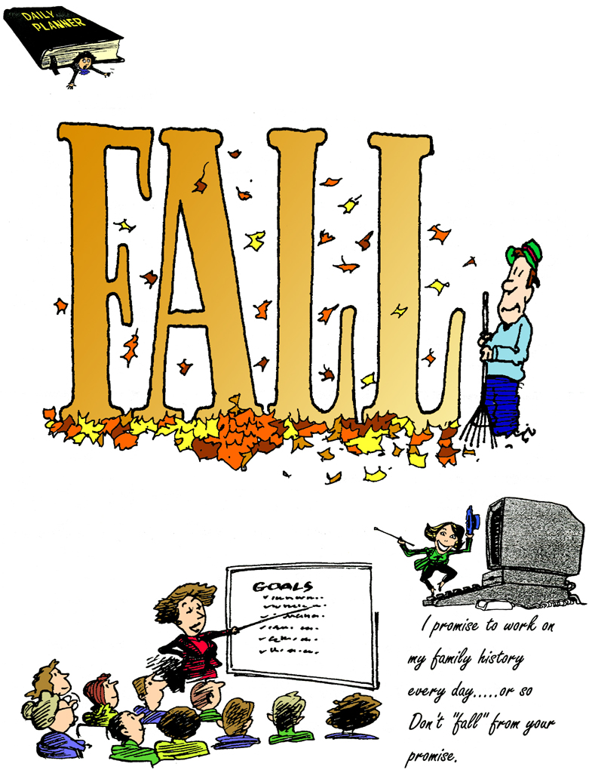

Indexers Are The Genealogist’s Best Friends

HSGS Web Site. <www.rootsweb.com/~usgenweb/mi/iosco/3501hsgs.htm> is the address for our HSGS's indexes on the Internet. The search engine for this site, or all of Michigan or any of the other Michigan’s counties is www.rootsweb.com/~usgenweb/mi/search.htm. We currently August 31 2004) 682 indexes, 17,358 printed pages, & 826,410 names indexed. The file size is 427MB. All these files are on HSGS’s CD, but only 95% are on the web site. The status of these indexes is as follows:
Master Index Status | Oct | Nov | Dec | Jan | Feb | Mar | Apr | May | Jun | Jul | Aug
On the web with a current date | 254 | 258 | 286 | 370 | 440 | 451 | 470 | 458 | 522 | 542 | 569
On the web with an outdated date | 125 | 122 | 124 | 99 | 100 | 101 | 101 | 113 | 75 | 74 | 71
Sent to the web site but not yet on | 10 | 4 | 3 | 0 | 0 | 0 | 0 | 0 | 0 | 0 | 0
New indexes not yet sent to web | 96 | 115 | 112 | 71 | 12 | 21 | 17 | 28 | 25 | 25 | 8
New indexes, not edited | 14 | 13 | 10 | 12 | 14 | 15 | 15 | 16 | 13 | 13 | 13
New indexes partially keypunched | 15 | 16 | 16 | 16 | 21 | 18 | 18 | 18 | 19 | 18 | 21
Total | 514 | 528 | 551 | 568 | 587 | 606 | 621 | 633 | 654 | 672 | 682

HSGS member Dan Stock is placing our indexes directly on our USGENWEB web site.

New Indexes added this month to HSGS’s Library & Web Site.
- Index To Herald: 1926 Apr, May, Jun & Jul. By Joan Doerr of Ellicott City MD.
- Index To United Methodist Church Directory: 2000. By Alonzo J Sherman of Oscoda MI.
- Index To Herald: 1937 Mar-May. By Alonzo J Sherman.
- Index To Vertical File #01. By Alonzo J Sherman.
- Index To Death Records: 1968-1969. By Charles Birnbaum of Tawas City MI.
- Index To Iosco County Plat Book: 1962. By Bonnie Petee of Swartz Creek MI.

New Books Added this Month to HSGS’s Library:
- Index To United Methodist Church Celebrates The Millennium: 2000. Donated by the Church.

Genealogical Records ready to be keypunched.
Pri | Folder | Name | Names | Owner | Comments
1 | BUS | Glass Negatives: 1892-1905, current index needs improvements (ICHS) | 3,000 | ICHS | KP only at the ICHS
1 | LAN | Plat Books for Iosco County MI: 1956, 1973, 1979 & 2001, about 2,000 name each | 8,000 | HSGS | KP anywhere
1 | LAW | 7 Justice of the Peace Records for East Tawas Village: 1945-1951 Civil; 1949-1952 Criminal; 1950s Criminal; 1951-1961 Civil; 1951-1961 Criminal; 1952-1956 Criminal; & 1955-1959 Civil (1,000-1,500 names each) | 10,000 | ICHS | KP locally
1 | NPG | Gazette Newspaper, 214 hard copy issues | 45,000 | AOHS | KP locally
1 | NPX | Obituaries on 3x5 cards | 1,000 | ICHS | KP at ICHS
1 | SCHO | Oscoda Area High School Yearbooks: 1979, 1984, 1986, 1987, 1988 & 1989 (about 2,000 names each) (HSGS) | 12,000 | HSGS | KP anywhere
2 | BUS | Telephone Directories, Tawases & Oscoda: 1964, 1970, 1964, 1970, about 1,000 names each | 4,000 | HSGS | KP anywhere
2 | MIL | Wurtsmith AFB Family Services Scrapbooks, 1960-1962, 1975-1972, 1973, 1976, 1978 & 1985, about 300 names for each book | 1,800 | AOHS | KP locally
2 | MIL | Wurtsmith AFB News: 1955-1993 (Weekly), about 100 names per issue | 200,000 | AOHS | Most KP in Parks Library & KP Duplicates locally
2 | MIL | Wurtsmith AFB Officers’ Wives’ Club Scrapbooks: 1951-1991, 27 books, about 250 names each | 6,750 | ICHS | KP locally
2 | MIL | Wurtsmith AFB Officers’ Wives’ Garden Club Scrapbooks: 1962-1974 4 books, about 250 names each | 1,000 | ICHS | KP locally
2 | MIL | Wurtsmith AFB Officers’ Wives’ Newsletter, The Warbler: 1963-1988 (about 250 names for each monthly | 72,000 | ICHS | KP locally
3 | HIS | Alcona-Iosco Retired Teachers’ Association Scrapbook: 1964-1972. | 1,500 | ICHS | KP locally
3 | HIS | Iosco Community Concert Association, 4 Scrapbooks: 1964-1994. | 4,000 | ICHS | KP locally
3 | HIS | Iosco Community Concert Association, Secretaries’ Book: 1976-1994. | 2,000 | ICHS | KP locally
4 | XBI | Michigan Biographies | 4,500 | PPL | KP locally
4 | XBI | Social Register Summer 1926, Detroit MI area © 1926 | 750 | HSGS | KP anywhere
4 | XCEM | Arenac County Michigan Cemetery Inscriptions | 7,000 | PPL | KP locally
4 | XED | University Of Michigan Yearbook: 1928 | 5,600 | HSGS | KP anywhere
4 | XGE | Short Family Tree: Descendants Of Samuel Short, Iosco & Other mid-Michigan Counties | 2,500 | HSGS | KP anywhere
4 | XIN | Native Americans In Michigan: A Bibliography of Material In the Clarke Historical Library | 550 | HSGS | KP anywhere
4 | XMI | Michigan’s Early Military Forces (partly done) | 8,000 | HSGS | KP locally
4 | XXX | Michigan Voices | 200 | HSGS | KP locally
4 | XXX | AuSable River Canoe Marathon: 1947-1997 | 4,000 | HSGS | KP anywhere
5 | XBI | Michigan Pioneer Society: 1877-1929, 40 Volumes, 3,750 names per issue | 150,000 | PPL | Must be done in Parks Library
5 | XED | Central Michigan University Commencement: 1979 | 4,000 | HSGS | KP anywhere
5 | XHI | The Northern Journal: Northern Michigan’s Magazine of Heritage, v1n1, v1n2, v1n3(missing), v1n4, v1n5, v1n6, v2n1, 2004Calendar, about 200 names each | 1,200 | HSGS | KP anywhere
5 | XMM | Biography Index to the Michigan Manuals: 1923-1973 | 30,000 | HSGS | KP in the Parks Library
5 | XMM | Michigan Manuals (Biographies Only) 1885-2002, 58 issues, about 300 names each | 17,400 | PPL | KP in the Parks Library
 |  |  | 611,850

Owners of the record: AOHS = AuSable-Oscoda Historical Society; HSGS = Huron Shores Genealogical Society; ICHS = Iosco County Historical Society; & PPL = Parks Public Library.
HSGS’s Treasurers Report. Savings $341.60, Checking $180.59, un-cashed checks $33.00, and cash on hand $25.00, = Total $580.19.
HSGS’s Jobs List (This will be a recurring article in this newsletter). It is necessary for other HSGS members to step forward and accomplish these jobs. The members currently working in the library are busy serving the patrons research needs, and do not have time left for this work. Note some of these jobs can be done in you home wherever you live, and some can only be done in your home if you live in the local area, and some need to be done in the library. Contact Mr Sherman if you can help at shermanaj@hotmail.com or 989-739-3650.
Job Name | Hrs | Location | Special Skills
File Box Liners, add cardboard liners to new file-boxes | 8 | Home (local only) or Library | None
File-box Labels, make labels for Index & Document file-boxes | 40 | Library | Typing
Letter 40 Pioneer Society book spines | 2-4hrs | Library | Gelink Pen (HSGS has)
Newsletter File Organized | 8 | Library | None
Project Officer for Poor Farm Cemetery |  | Spartan Rd, Tawas City | Lawn mower & trimmer
Proper shelving of books, check for | 1 wkly | Library | None
Time Report- Help design & maintain HSGS Time Report (For stats for future grants etc) | 4 mo | Home (anywhere) | Computer, Excel or Word (tables), & Email
Abrams Genealogy Series- 2004. Contact <www.Michigan.gov/hal> for info. (Flint Gen Soc Newsletter v27n2 March 2004).
Oct 2 | Ship’s Passenger Lists
Dec 4 | Finding your 20th Century Ancestors
Tawas City 1903. The most disgusting sight that greets the eyes of strangers in our city at present is the numerous decorations of our sidewalks, which evidences the fact that cows are allowed to run at large. (Submitted by Jim Farrand from the Tawas Herald, May 15 1903).
HURON SHORES GENEALOGICAL SOCIETY ACTIVE MEMBERS. C/o Robert J Parks Public Library, 6010 N Skeel Ave, Oscoda MI 48750, and Phone 989-739-9581. The Library is open Mon, Fri & Sat 9:00am-5:00pm & Tue-Wed-Thur 9am-8:00pm (HSGS member available 9:00am-3:00pm Sat). HSGS’s meetings are 7-8pm the 3rd Thursday of Jan, Apr, and Jul & Oct in the Oscoda Library. Officers, project leaders & active indexers are listed below:
Name | Current Projects | E-mail | Phone
Beuthin, Rancy | Indexing Pioneer Society | <arby@speed2u.net>
Birnbaum, Charles | Iosco County Death Indexes, News Herald Index, Saginaw News Obits etc | <Birnbaumcr@hotmail.com> | 989-362-5994
Brewer, Karen | Transcribing various cemetery records | <kfolly@earthlink.net> | 810-749-2830
Burns, Samantha | Transcribing various records |  | 989-7397431
Carraway, Marianne | 1963 & 1977 Hale Year Books | <mcarraway@charter.mi.net> | 989-739-9569
Daley, Lawrence | Hale Yearbook 1901-2002 | <daleymart@msn.com> | 248-253-7472
Dingus, Ginger Metcalf | Secretary, Transcribing various records | <gingey326@hotmail.com> | 989-820-0078
Doerr, Joan | Tawas Herald Newspaper Index | <JoanDoerr@hotmail.com> | 410-461-1407
Donaldson, James | Assists with His Oscoda Press Collection | <ab6943@wayne.edu> | 313-835-2440
Dressel, David | Transcribing various records | <ddressel@mail.cyberspeedway.net> | 480-838-4744
Durkin, Thomas | Transcribing various records | <TomPatDurkin@aol.com> | 904-273-8053
Farrand, Jim | Transcribing various records | <farrand@chartermi.net> | 989-469-2308
Foust, Ruby | Transcribing various records | <lfoust@tampabay.rr.com> | 352-799-2604
Groff, Jan | Transcribing various records | <jalynn1G@yahoo.com> | 989-362-6777
Huebner, Christine | Transcribing various records | <delnorte@voyager.net> | 989-362-7423
Klenow, Rosemary | President | <klenowr@alpena.cc.mi.us> | 989-362-5425
Kruszka, Anne Percival | Iosco County Gazette Index | <ackruszka@wmconnect.com> | 734-261-6416
Lascon, Diana | Transcribing various records | <dlacson_2000@yahoo.com> | 510-487-5729
Petee, Bonnie | Transcribing various records | <gypsy2@chartermi.net> | 810-636-9348
Schoonover, Duane | Transcribing various records | <duane881@hotmail.com> | 989-820-0078
Selbrede, Jennifer | Tawas Herald Newspaper Index | <jen@postoffice.ccis.com> | 760-373-2204
Sheldon, Judy | Treasurer | <jsheldon@amaesd-net.com> | 989-739-5497
Sherman, Alonzo | Librarian/Publications | <shermanaj@hotmail.com> | 989-739-3650
Stevens, Grace | School Yearbooks Index | <GraceACE@aol.com> | 616-349-7840
Stock, Dan | Putting HSGS indexes on the Web Site | <etts95@yahoo.com> | 989-739-4239
Stonehouse, Naomi | Vice-President | <alvene2000@yahoo.com> | 989-362-8187
Summers. Leona | Oscoda Press Index | <no email> | 989-724-6510
Whitford, Sandy | Indexing HS Yearbooks | <wumpw@yahoo.com> | 989-362-3679
Yorkell-Parker, Sandra | Indexing Pioneer Society | <syparker@nidlink.com>
Newberry Library’s Family History Open House. The Newberry Library in Chicago announces its Family History Open House on October 23rd, 2004. The Open House is the Newberry’s most popular genealogy event as it’s designed to get visitors started with their family history research. The event features free lectures, tours, and information booths that will acquaint visitors with the Newberry Library’s facilities, staff, and resources. A must for all of those beginners out there. Admission is free. For more information, visit http://www.newberry.org/nl/genealogy/L3gfriends.html. (GenWeekly.com v1n6 Aug 12 2004).
FEEFHS Conference in Detroit. The Federation of East European Family History Societies, or FEEFHS, will host its 11th Annual International Convention at the Crowne-Plaza Detroit-Metro Airport. The topics at FEEFHS conferences always include genealogical resources, research techniques, databases, projects in all European countries east of and including Germany and Austria. Within this general format, specific lectures and workshops pertain to U.S. immigration records, European emigration records, Germanic and Slavic genealogy, internet resources for eastern European genealogy, web page design, Eastern European databases, and Polish, Ukrainian, Russian, Baltic, and Balkan research. (GenWeekly.com v1n6 Aug 12 2004).
A PhD in Family History? For the first time a fully accredited university has awarded a Ph.D. in the field of Family History/Genealogy. The Union Institute & University of Cincinnati, OH granted the earned degree on 31 March 2004 to Nelson A.L. Weller. His dissertation, some 500 pages long, is entitled “The Schauss/Shouse family in North Carolina, 1620-1900”. Weller says “UI&U was the only fully accredited university in the USA that could be found which would accept me for work in the field of Family History/Genealogy”. In order to obtain the degree, Weller had to add a Certified Genealogist with a Ph.D. to my doctoral committee. Dr. Alice Eichholz, author of the Red Book, who is on the faculty of UI&U's Vermont College, filled this position. He also had to write a contextual essay that justified this field as a legit academic subject at the doctoral level. Nelson A.L. Weller is 74 year old retired minister, who has been doing family history as a hobby since 1948. Although he is the first to obtain a Ph.D. in Family History from an accredited university, he believes other doctoral programs may be forthcoming. (GenWeekly.com v1n5 Aug 5 2004).
Judy Sheldon and her daughter. Lauren Altenbernt, spent three days in the U.P. in August site seeing and doing a bit of family searching. Lauren is a member of the Keweenaw Bay Indian Community through her paternal grandmother. She is trying to verify information obtained through the membership process and expand the family history. Despite the rain, they were able to visit the Pinery Indian Cemetery in Zeba where many members of her family are buried. One big difference between Native American cemeteries and non-Native American ones is the use of Spirit huts to mark the graves. These are made of wood and there are no name markers. Some graves are marked with head stones. Fortunately for Lauren, some of her family used stone markers with names and dates engraved on them. They found one possible 3-great grand mother who was 107 years old! The other good fortune was the Baraga County Court House in L'Anse. They were the most cooperative and pleasant people anyone could ask for! The trip ended with as many questions as they found answers. (Isn't that what always happens?) Next year is already in the works--a trip to the Soo and the Bay Mills Indian Community. Since their return home, they have discovered a very helpful Yahoo group, 3fires, People of the 3 Fires. If anyone out there knows anything about the family of Tyosh/Tiosh please e-mail Judy Sheldon. (By Judy Sheldon).
Lawsuit Over Familysearch Name. Robert Sintes devotes his time to a noble cause—trying to re-unite lost children with their family members. However, Sintes is now engaged in a fight with The Church of Jesus Christ of Latter-day Saints over the use of the term “familysearch”. The Church is trying to stop Sintes from using the name that they have trademarked. Sintes set up his www.familysearch.co.nz website to advertise his services, run through the New Zealand Family Tracing Service. The Church’s well-established family history website is found at www.familysearch.org. Sintes has defended himself in court, arguing that the words "family" and "search" are common words often used together by people making Internet searches. Intellectual Reserve Inc and the Corporate of the President of the Church of Jesus Christ of Latter-day Saints sued him for using their trademarked name.
The church would like Sintes to hand over ownership of www.familysearch.co.nz. It claims exclusive rights to the name and trademark "familysearch" and has been promoting its name in New Zealand for more than 10 years. Apparently, trademarks do not extend to the .nz domain; it is not clear whether they provide protection for the words preceding the domain in the online environment. Sintes says he will fight his case in the courts. He has been told it would cost him $70,000 if he employed a lawyer. He says he will do what he has to do to win this battle. (GenWeekly v1n2 July 16 2004).
Userfull Calculators. See web site <www.searchforancestors.com/utility/>. (Editor).
Sources2Go.com.This web site houses thousands of digitized government records that can be browsed to further your genealogical and family history research. If you find an image that you like, you can order a high quality version of the image on CD-ROM. There are currently 100,508 images available for browsing on the Sources2Go.com site. (Dick Eastman Newsletter August 22 2004).
Copyright Laws. You can read Lloyd J. Jassin's "New Rules For Using Public Domain Materials" at http://copylaw.com/new_articles/PublicDomain.html (Dick Eastman Newsletter August 22, 2004
Everton’s Family History Company. The assets of Everton’s Family History Company were donated to the city of Logan, Utah. You can click on the link below to read an article about it in the Salt Lake Tribune: http://166.70.44.66/2004/Jul/07132004/utah/183027.asp. Because of our former association with Everton, we receive many queries about the whether or not subscribers to the Family History Magazine would continue to have something to be subscribed to. It is our understanding that Logan intends to honor every existing subscription. We advise that customers of Everton’s monitor the city’s website, www.ci.logan.ut.us, for more information. Also, you may want to continue to watch for the reemergence of the Everton website, www.everton.com, for the time when it comes back online. (GenWeekly v1n2 July 16 2004).
Genealogical Helpers. HSGS has about 3 banker boxes full in excess to our needs. If you have the need come and get them at my home at 308 W Dwight in Oscoda. You must do the sorting & selecting as there is no list of issues available. (Alonzo J Sherman 989-739-3650 or <shermanaj@hotmail.com>).
Genealogy One-on-One at the Flint Public Library (1026 E Kearsley St). Saturday October 16 2004 from 10am – 2pm the library staff & Genealogical Society members will be there to help. (Flint Gen Soc Newsletter v27n6 Sep 2004).
Family History Month 2004 Genealogical Seminar. Saturday Oct 16 2004 from 9am-4pm there will be 12 classes at the Library of Michigan. For more info see www.rootsweb.com/mimgc. (Flint Gen Soc Newsletter v27n6 Sep 2004).

HURON SHORES GENEALOGICAL SOCIETY
C/o Robert J Parks Public library
6010 N Skeel Ave
Oscoda MI 48750

Genealogical work crew

