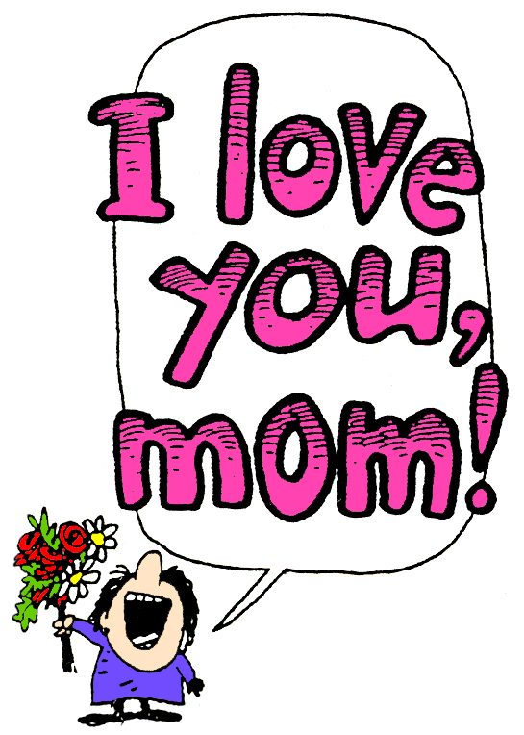
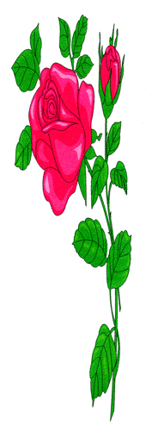


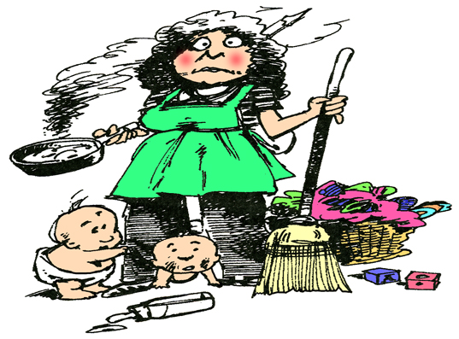



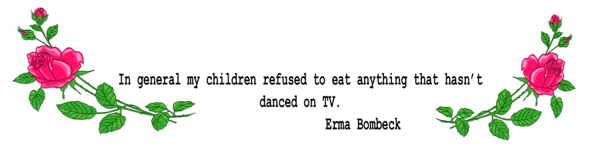

Indexers Are The Genealogist’s Best Friends

HSGS Web Site. <www.rootsweb.com/~usgenweb/mi/iosco/3501hsgs.htm> is the address for our HSGS's indexes on the Internet. The search engine for this site, or all of Michigan or any of the other Michigan’s counties is www.rootsweb.com/~usgenweb/mi/search.htm. We currently have (April 28 2005) 778 indexes, 20,569 printed pages, & 967,242 names indexed. The file size is about 550MB. All these files are on HSGS’s CD, but only 92% are on the web site (does not include new indexes within the last month, draft indexes not yet finished, & a some random data corrections). The status of all indexes is as follows:
Master Index Status | May | Jun | Jul | Aug | Sep | Oct | Nov | Dec | Jan | Feb | Mar | Apr
On the web, current date | 458 | 522 | 542 | 569 | 598 | 607 | 625 | 627 | 648 | 655 | 665 | 675
On the web, outdated date | 113 | 75 | 74 | 71 | 60 | 60 | 49 | 49 | 49 | 49 | 49 | 49
New, not yet sent to web | 28 | 25 | 25 | 8 | 8 | 7 | 3 | 22 | 6 | 11 | 11 | 11
Future, being edited | 16 | 13 | 13 | 13 | 12 | 13 | 13 | 13 | 15 | 14 | 14 | 14
Future, partially keypunched | 18 | 19 | 18 | 21 | 30 | 30 | 31 | 31 | 31 | 29 | 29 | 29
Total | 633 | 654 | 672 | 682 | 708 | 717 | 721 | 742 | 749 | 758 | 768 | 778

HSGS member Dan Stock is placing our indexes directly on our USGENWEB web site.

HSGS’s Treasurers Report (04/20/2005). Savings $684.53, Checking $1,042.75, cash on hand $25.00 = Total $1,752.28.

New Indexes added this month to HSGS’s CD-ROM & Web Site:
- Index To Tawas Herald: Aug, Sep, Oct 1924. Indexed by Joan Doerr of Ellicott City MD.
- Index To Wurtsmith News: 1993 (The Final Approach). Indexed by Alonzo J Sherman of Oscoda MI.
- Index to The First Michigan Frontier: 1763+. Indexed by Alonzo J Sherman.
- Index To Detroit Tigers: 1901-1981. Indexed by Alonzo J Sherman.
- Index To Lake Huron: 1615+. Indexed by Alonzo J Sherman.
- Index To Historic Women Of Michigan. Indexed by Alonzo J Sherman.
- Index To Saginaw Library’s Obituary Abstracts of Iosco County residents. Indexed by Alonzo J Sherman.

Materials transferred to HSGS’s Library this month from the Parks Library book weeding program:
- Ireland: A Cultural Encyclopedia, by Brian DeBreffny, ©1983, 2546 pages.
- Too Long A Sacrifice- Life and Death in Northern Ireland Since 1969, by Jack Holland, ©1981, 217 pages.
- Northern Ireland, by Jonathan Bartlett, ©1983, 167 pages.
- Irish History and Culture- Aspects of a People’s Heritage, by Harold Orel, ©1976, 387 pages.
- Detroit Tigers, by Joe Falls, ©1975, 192 pages.
- The “995” Tigers, by Fred T Smith, ©1881, 232 pages.
- Michigan, by John Calkins, ©1967, 62 pages.

New Materials added to HSGS Library this month:
- 2005 Iosco County Michigan Plat Book. Donated by Ginger Dingus.

New Materials added to Robert J Parks Public Library this month:
- Genealogy 101- How to Trace Your Family’s History and Heritage, by Barbara Renick, ©2003 by National Genealogical Society, 241 pages (Call Number 929.1/Re).
- Planting Your Family Tree Online- How to Create Your Own Family History Web Site, by Cyndi Howells, ©2003 by National Genealogical Society, 259 pages (Call Number 929.1/Ho).

Note. These two books are at the Parks Library through June 2005, and then they will rotate to other libraries in the Iosco-Arenac District Library. Their current location can be found by checking the library’s card catalog.

HSGS Records ready to be keypunched:
Pri | Folder | Name | Names | Owner | Comments
1 | BUS | Glass Negatives: 1892-1905, current index needs improvements (ICHS) | 3,000 | ICHS | KP only at the ICHS
1 | LAN | Plat Books for Iosco County MI (Advertising): 1984, 1996 & 2005, about 900 names each | 2,700 | HSGS | KP anywhere
1 | LAN | Plat Books for Iosco County MI (personal Names): 1949?, 1963, 1967, 1970, 1973,1979, 2001 & 2005 about 2,000 names each | 16,000 | HSGS | KP anywhere
1 | LAW | 7 Justice of the Peace Records for East Tawas Village: 1945-1951 Civil; 1949-1952 Criminal; 1950s Criminal; 1951-1961 Civil; 1951-1961 Criminal; 1952-1956 Criminal; & 1955-1959 Civil (1,000-1,500 names each) | 10,000 | ICHS | KP locally
1 | MIL | Wurtsmith AFB News: 1955-1993 (Weekly), about 100 names per issue | 200,000 | AOHS | Most KP in Parks Library & KP Duplicates locally
1 | NPG | Gazette Newspaper, 214 hard copy issues | 45,000 | AOHS | KP locally
1 | NPX | Obituaries on 3x5 cards | 1,000 | ICHS | KP at ICHS
2 | BUS | Phone Book: Hale, Glennie & Whittemore: 1968. | 1,000 | HSGS | KP anywhere
2 | BUS | Phone Book: Oscoda, 1964, 1970, about 1,000 names each | 2,000 | HSGS | KP anywhere
2 | BUS | Phone Book: Tawases 1964, 1970, about 1,000 names each | 2,000 | HSGS | KP anywhere
2 | MIL | Wurtsmith AFB Officers’ Wives’ Club Scrapbooks: 1951-1991, 27 books, about 250 names each | 6,750 | ICHS | KP locally
2 | MIL | Wurtsmith AFB Officers’ Wives’ Garden Club Scrapbooks: 1962-1974 4 books, about 250 names each | 1,000 | ICHS | KP locally
2 | MIL | Wurtsmith AFB Officers’ Wives’ Newsletter, The Warbler: 1963-1988 (about 250 names for each monthly | 72,000 | ICHS | KP locally
2 | SCHO | Oscoda Area High School Yearbooks: 1984, 1986, 1987, 1988 & 1989 (about 2,000 names each) (HSGS) | 12,000 | HSGS | KP anywhere
3 | HIS | Alcona-Iosco Retired Teachers’ Association Scrapbook: 1964-1972. | 1,500 | ICHS | KP locally
3 | HIS | Iosco Community Concert Association, 4 Scrapbooks: 1964-1994. | 4,000 | ICHS | KP locally
3 | HIS | Iosco Community Concert Association, Secretaries’ Book: 1976-1994. | 2,000 | ICHS | KP locally
4 | XBI | Michigan Biographies | 4,500 | PPL | KP locally
4 | XBI | Social Register Summer 1926, Detroit MI area © 1926 | 750 | HSGS | KP anywhere
4 | XCEM | Arenac County Michigan Cemetery Inscriptions | 7,000 | PPL | KP locally
4 | XED | University Of Michigan Yearbook: 1928 | 5,600 | HSGS | KP anywhere
4 | XIN | Native Americans In Michigan: A Bibliography of Material In the Clarke Historical Library | 550 | HSGS | KP anywhere
4 | XMI | Michigan’s Early Military Forces (partly done) | 8,000 | HSGS | KP locally
4 | XXX | AuSable River Canoe Marathon: 1947-1997 | 4,000 | HSGS | KP anywhere
5 | XBI | Michigan Pioneer Society: 1877-1929, 40 Volumes, 3,750 names per issue | 150,000 | PPL | Must be done in Parks Library
5 | XED | Central Michigan University Commencement: 1979 | 4,000 | HSGS | KP anywhere
5 | XHI | The Northern Journal: Northern Michigan’s Magazine of Heritage, v1n1, v1n2, v1n3(missing), v1n4, v1n5, v1n6, v2n1, 2004Calendar, about 200 names each | 1,200 | HSGS | KP anywhere
5 | XMM | Michigan Manuals (Biographies Only) 1885-1921, 32 issues, about 300 names each | 9,600 | PPL | KP in the Parks Library
5 | XMM | Michigan Manuals (Biographies Only) 1975-2005, 30 issues, about 300 names each | 9,000 | PPL | KP in the Parks Library
 |  |  | 586,150

Owners of the record: AOHS = AuSable-Oscoda Historical Society; HSGS = Huron Shores Genealogical Society; ICHS = Iosco County Historical Society; & PPL = Parks Public Library.

HSGS’s Jobs List. It is necessary for other HSGS members to step forward and accomplish these jobs. The members currently working in the library are busy serving the patrons research needs, and do not have time left for this work. Note some of these jobs can be done in you home wherever you live, and some can only be done in your home only if you live in the local area, and some need to be done in the library. Contact Mr Sherman if you can help at shermanaj@hotmail.com or 989-739-3650.

Job Name | Hrs | Location | Special Skills
Letter 40 Pioneer Society Book spines | 2-4hrs | Library | Gelink Pen (HSGS has)
New Labels on Gazette Microfilm cans/boxes, that include roll # & date span. 36 cans/boxes. | 2 days | Library | Computer, label program
Project Officer for Poor Farm Cemetery | 1 wk/yr | Spartan Rd, Tawas City | Lawn mowing/trimming
Proper shelving of books, check for | 1 wkly | Library | None
Time Report- Help design & maintain HSGS Time Report (For stats for future grants etc) | 4 mo | Home (anywhere) | Computer, Excel or Word (tables), & Email

Online Searchable Military Records & Databases. This site has a large number of military databases from the Revolutionary War to the Vietnam War, see home.att.net/~wee-monster/military.html. (Saginaw Gen Soc Newsletter v27n9p393, April 2005).

Web Sites For United States Veterans. (Access, v21n5 Nov/Dec 2004)Dec 2005):

Organization | Web Site
House Committee on Veterans Affairs | http://veterans.house.gov
National Archives- Access to Military Service and Pension Records | www.archives.gov/research_room/obtain_copies/veterans_service_records.html
National Veterans Organization of America | www.nva.org
Official Site of Veterans of Foreign Wars of the United States | www.vfw.org
Sons of Confederate Veterans of the Civil War | www.scv.org/membership/genealogy.asp
Sons of Union Veterans of the Civil War | http://suvcw.org/gene,htm
Veterans Benefits Administration, Department of Veterans Affairs | www.vba.va.gov
Veterans History Project of the Library of Congress | www.loc.gov/folklife/vets
VFW National Home for Children (only one in the US- Eaton Rapids MI) | www.vfwnationalhome.org

American Indian Museum. Opened September 2004 in Washington DC. (Sag Gen Soc Newsletter v27n4p379, Jan 2005).

AncestryPlus & ProQuest. Library of Michigan will continue to provide AncestryPlus on-line to Michigan public libraries for in-library use through July 30 2005.

Starting August 1 2005 through September 30 2006, ProQuest’s product called Ancestry Library Edition will be provided by the Library of Michigan for in-library use to Michigan public libraries via the Internet. All AncestryPlus files will be included except those listed below, and some new files included are listed below:

Ancestry Plus Files Deleted | ProQuest New Files Added
Biography & Genealogy Master Index
(This will still be available through a separate MEL database)
Philby Passenger Lists 1851-1891
315 City Directories (Check out www.citydirectories.com)
 | NY Passenger Lists 1851-1891
 | Wuetemberg Emigration Index late 18th century to 1900 (Also available in hard copy at HSGS.
 | NY Petitions for Naturalization 1792-1906
(Dearborn Gen Soc Newsletter v26n1, Fall 2004, as reprinted in the Sag Gen Soc Newsletter v27n4p380, Jan 2005).

University of Michigan Digital Library (UMDL). There are 37 collections in this digital library, and all pages are fully viewable and searchable. One of the most interesting for genealogist is the Michigan County Histories. See www.hti.umich.edu/m/micounty. (Sag Gen Soc Newsletter v27n4p380, Jan 2005).

Counties In Time, An Irish History CD. Eneclann has published this CD-ROM, which includes 1,000 documents from the National Archives of Ireland from the late 16th century to the mid 20th century. Cost is $29.95. See www.eneclann.ie/publications-8.asp. (Sag Gen Soc Newsletter v27n4p380, Jan 2005).

Linkpendium. The creators of Rootsweb, which was acquired by Ancestry.com in 2002, have started a new project called Linkpendium. See www.linkpendium.com. (Sag Gen Soc Newsletter v27n4p381, Jan 2005).

Canadian Atlas. Includes maps of 1740-1823 as well as more modern maps. See www.gc.ca. (Sag Gen Soc Newsletter v27n4p382, Jan 2005).

The Wayback Machine. The site is an archive of some web sites that have been closed down since 1996. For more info see www.archive.org/. (Sag Gen Soc Newsletter v27n4p382, Jan 2005).

England & Wales General Record Office. This site now offers online ordering service for worldwide patrons. For info see www.gro.gov.un. (Sag Gen Soc Newsletter v27n5p383, Feb 2005).

The Genealogical Death Indexing System (GENDIS) Program. Currently includes 205,000 Michigan deaths from 1867-1885. See <www.mdch.state.mi.us/pha/osr/gendisx/search2.htm>. (MI Gen Council Newsletter v29i2p5, Spring 2005).

Some Genesee County Michigan Records. See www.taylorsrecords.org. (Sag Gen Soc Newsletter v27n5p384, Feb 2005).

Dutch Civil Records. Records kept since 1811. They become public domain after 50 years for death records, 75 years for marriage records, and 100 years for birth records. For more info see www.genlias.nl. (Sag Gen Soc Newsletter v27n5p385, Feb 2005).

Ancestral And Family Data Sheets. For colorful and easy-to-understand data sheets, see www.ancestryprinting.com/family.html. (Sag Gen Soc Newsletter v27n5p385, Feb 2005).

Ellis Island Database Help. Stephen Morse and volunteers have gone through all 3,700 rolls of microfilm covering 1892-1924, which includes 84,000 ships. For those who used the Ellis Island database and have not found there ancestors, maybe because miss spelled names, can search this data base by immigrant’s name, ship’s name or the date of arrival. This database consists of full page images that you can read and interpret your self. See <http://stevemorse.org/ellis/boat.html>. (Sag Gen Soc Newsletter v27n5p386, Feb 2005).

Swedish Church Records Online. See www.genline.com. (Sag Gen Soc Newsletter v27n5p386, Feb 2005).

Bibliography of Southwest Michigan Local/Family History Resources. A six-year project of cataloging 52 libraries in Southwest Michigan. The 3,000 entry bibliography was prepared by Toni Benson, local history librarian for the Van Buren District Library, and a genealogist for 23 years. (Kalamazoo Valley Heritage v29n7p2 April 2005).
Michigan Department of Community Health Records at the Library of Michigan. (MI Gen Council Newsletter v29i2p7, Spring 2005).

Vital Records | Years | Type | Library of MI Microfilm Location
Births | 1867-1915 | Index | F 565.I5 1960
Marriages | 1867-1921 | Index | F 565.I54 1960
Marriages | 1950-1969 | Index | F 565.I54 1950
Marriages | 1967-1925 | Returns | F 565.154
Divorces | 1897-1969 | Index | F 565 D58 1960
Divorces | 1897-1922 | Summary | F 565 D57 1897
Deaths | 1867-1914 | Index | F 565.I53 1960
Deaths | 1971-1996 | Index | (Available on Ancestry.com)
Deaths | 1867-1897 | Returns | F 565.I53 1868

Michigan Vital Records Historical Facts. (MI Gen Council Newsletter v29i2p6-7, Spring 2005).

Year | Act |  | Action
1867 | 194 | a | “An Act to provide for the registration of births, marriages and deaths.” This was Michigan’s first vital records registration law. Each township or city has to take an “actual assessment by actual inquiry or otherwise, of the inhabitants thereof, the births and deaths.”
1867 | 194 | b | Births: Date of births; name of the child; sex of the child; Place of birth; Christian and surname of both parents; residence and nativity of the parents; occupation of the father; and date when the records was made.
1867 | 194 | c | Marriages: Date and place of marriage; Christian and surnames of the bridegroom and the bride; age and place of births of each; residence of each at the time of marriage; occupation of the bridegroom; name and official station of the person by or before whom they were married; names and residence of at least two witnesses present at such marriage; and date when such records was made.
1867 | 194 | d | Deaths: Date of death; Christian and surname of the deceased; sex; whether married or single; age in years, months and days; the place of death; disease or apparent cause of death, nativity of the deceased; occupation if over ten years of age (if under that age, the names and residence of the parents, if known; date when such record was made.
1869 | 125 |  | Moves the reporting year from April through March to January through December starting in 1870. The returns for 1860 are from 5 April to 31 December. A new column was added to each record for the color of the child, bridegroom and bride, and the deceased. The columns for the deceased was changed to the “residence of the parents, if known.”
1887 | 128 |  | Requiring a civil license in order to marry and the registering of them beginning in 1888. Parents of the parties are listed for the first time.
1897 | 009 | a | The beginning of statewide recording of divorces.
1897 | 009 | b | Divorces: Record number; full name of each party; age of each in years; date of marriage by month/day/year; place of marriage; number of children in family; complainant husband or wife; date of filing application by month/day/year; date of final action by month/day/tear; alleged causer for divorce; was the case contested or not?; whether granted, refused, withdrawn or otherwise disposed of or pending at the end of the year; whether divorce was absolute or conditions, if any.
1897 | 180 |  | Private marriages by the Probate Court (child on the way).
1897 | 217 |  | Provided for the registration of deaths and the issuing of death certificates that began in 1898.
1905 | 330 |  | Provide for the immediate registration of births and issuing of birth certificates beginning with 1906.
1921 | 170 |  | Responsibility for Michigan vital records was transferred from the Secretary of State to the State Commission for Health.
1925 | 343 |  | First major revision of the vital records laws.
1931 | 035 |  | The first provision for delayed birth records (anticipating social security).
1933 | 105 |  | Illegitimate births are no longer recorded in the county records, the only records of such births are kept by the State Vital Records Office in a file that’s closed to the public.
1953 | 100 |  | Adoption is no longer mentioned on birth certificates starting from 21 May 1853.
1968 | 213 |  | Original certificate of births and records of adoption shall not be subject to public disclosure except by court order or permission of the Public Health Director.
1978 | 368 |  | Also known as the Public Health Code. The second major revision of the vital record laws. Birth records are made more restrictive, the term illegitimate birth is dropped and such births are again recorded at both state and county level.
1997 | 054 |  | Birth records 110 years or more can be released to any applicant.
2002 | 544 |  | Birth records 100 years or more cane be released to any applicant.

Michigan’s Vital Records Office Fee Chart. Effective Dec 29 2004.

Service | New Fee
First copy of a vital record | $26.00 Includes 3 year search
Addition copies of same record | $12.00
Additional years searched (each) | $12.00
First copy for exemplified record | $29.00
Additional copy of Exemplified record | $15.00
Verification of vital records facts | $10.00
Expedited search fee via mail | $10.00
Same day service when applying in person | $10.00 2-3 hour waiting period
Creation of delayed birth record | $40.00
Creation of Foreign Born Birth Record | $40.00
Changes to vital records | $40.00
Veteran’s use only copy | $0.00
Senior citizen copy of their birth record | $7.00
Note: Search fees are non-refundable. A search fee covers the cost of a basic three year search (the year submitted and one year before and after).

HURON SHORES GENEALOGICAL SOCIETY ACTIVE MEMBERS. C/o Robert J Parks Public Library, 6010 N Skeel Ave, Oscoda MI 48750, and Phone 989-739-9581. The Library is open Mon, Fri & Sat 9:00am-5:00pm & Tue-Wed-Thur 9am-8:00pm (HSGS member available 9:00am-3:00pm Sat). HSGS’s meetings are 7-8pm the 3rd Thursday of Jan, Apr, and Jul & Oct in the Oscoda Library (This may change in 2005, so call before coming). Officers, project leaders & active indexers are listed below:
Name | Current Projects | Phone & E-mail
Beuthin, Rancy | Indexing Pioneer Society | 231-825-9773 <arby@speed2u.net>
Birnbaum, Charles | Iosco County Death Indexes, News Herald Index, Saginaw News Obits e | 989-362-5994 <Birnbaumcr@hotmail.com>
Brewer, Karen | Transcribing various cemetery records | 810-749-2830 <kfolly@earthlink.net>
Burns, Samantha | Transcribing various records | 989-739-7431 <none>
Carraway, Marianne | Hale Year Books | 989-739-9569 <mcarraway@charter.mi.net>
Daley, Lawrence | Hale Yearbook 1901-2002 | 248-253-7472 <daleymart@msn.com>
Dingus, Ginger Metcalf | Secretary, Transcribing various records | 989-362-4706 <gingey326@hotmail.com>
Doerr, Joan | Tawas Herald Newspaper Index | 410-461-1407 <JoanDoerr@hotmail.com>
Donaldson, James | Assists, His Oscoda Press Collection | 313-835-2440 <ab6943@wayne.edu>
Dressel, David | Transcribing various records | 480-838-4744 <ddressel@mail.cyberspeedway.net>
Durkin, Thomas | Transcribing various records | 904-273-8053 <TomPatDurkin@aol.com>
Farrand, Jim | Transcribing various records | 989-469-2308 <farrand@chartermi.net>
Foust, Ruby | Transcribing various records | 352-799-2604 <lfoust@tampabay.rr.com>
Groff, Jan | Transcribing various records | 989-362-6777 <jalynn1G@yahoo.com>
Huebner, Christine | Transcribing various records | 989-362-7423 <delnorte@voyager.net>
Klenow, Rosemary | Vice-President | 989-362-5425 <klenowr@alpena.cc.mi.us>
Kruszka, Anne Percival | Iosco County Gazette Index | 734-261-6416 <ackruszka@wmconnect.com>
Lascon, Diana | Transcribing various records | 510-487-5729 <dlacson_2000@yahoo.com>
Petee, Bonnie | Transcribing various records | 810-636-9348 <gypsy2@chartermi.net>
Schoonover, Duane | Transcribing various records | 989-820-0078 <duane881@hotmail.com>
Selbrede, Jennifer | Tawas Herald Newspaper Index | 760-373-2204 <jen@postoffice.ccis.com>
Sheldon, Judy | Treasurer | 989-739-5497 <judesheldon@yahoo.com>
Sherman, Alonzo | Librarian/Publications | 989-739-3650 <shermanaj@hotmail.com>
Stevens, Grace | School Yearbooks Index | 616-349-7840 <GraceACE@aol.com>
Stock, Dan | Putting indexes on the Web Site | 989-739-4239 <etts95@yahoo.com>
Stonehouse, Naomi | President | 989-362-8187 <alvene2000@yahoo.com>
Summers. Leona | Oscoda Press Index | 989-724-6510 <none>
Whitford, Sandy | Indexing HS Yearbooks | 989-362-3679 <wumpw@yahoo.com>
Yorkell-Parker, Sandra | Indexing Pioneer Society | ???-???-???? <syparker@nidlink.com>

TRAINING AVAILABLE (One Time)
(April-May offers the most training sessions of the whole year- Catch the Wave!)
Yr/Mo/Day | Description
2005/05/07  Sat | Genealogy Workshop sponsored by the River Aux Sable DAR. 9:30am-1:30pm at the Parks Library in Oscoda MI. Contact Mrs Merwin 989-739-9394.
2005/05/10  Tue | Bus Trip To Allen County Public Library, Fort Wayne, Indiana. By the Flint Genealogical Society. For info see www.rootsweb.com-mifgs/.
2005/05/12  Thur | State Archives Workshop-Genealogy Series. Military Records at the State Archives. Contact 517-373-1408 or archives@michigan.gov.
2005/05/27-29  Fri-Sun | The Ontario Genealogical Society- Cross Border Heritage Seminar. Located at the Clearty Auditorium in Windsor Ontario. For more info see www.ogsseminar.org.
2005/06/01-04  Wed-Sat | 2005 National Genealogical Society & GENTECH Conference, by Middle Tennessee Genealogical Society, Nashville TN.
2005/06/04  Sat | Abrams Genealogy Series. French-Canadian Genealogy. At Library of Michigan in Lansing MI. Contact 517-373-1300.
2005/06/04  Sat | National Genealogical Society’s Annual Conference, in Nashville TN. For info go to www.ngsgenealogy.org.
2005/06/09-11  Thur-Fri | Palatines to American Celebrating 30 years of Palatines to American. At FtWayne IN. Contact ralphkroehler@prodigy.net.
2005/06/18  Sat | Michigan Genenalogical Council Workshop- The Future of Genealogy: Are Seminars Still Feasible? 9am-4:30pm Library of Michigan, Lake Ontario Room. Flyers pending.
2005/07/14  Thur | State Archives Workshop-Genealogy Series. Land Ownership & Historical Homes. Contact 517-373-1408 or archives@michigan.gov.
2005/07/29-30  Fri-Sat | Land Records & Genealogy Symposium. Southeast Community College, Beatrice Nebraska. Contact Kelly Morgan at kmorgan@southeast.edu or 800-233-5027.
2005/08/06  Sat | Abrams Genealogy Series. State Census Records. At Library of Michigan in Lansing MI. Contact 517-373-1300.
2005/10/01  Sat | Abrams Genealogy Series. New England Genealogy Research. At Library of Michigan in Lansing MI. Contact 517-373-1300.
2005/10/19-20  Fri-Sat | Midwestern Roots 2005: Family History & Genealogy Conference, Indianapolis IN. www.indianhistory.org/midwesternroots/.
2005/12/03  Sat | Abrams Genealogy Series. Finding Your Irish Ancestors. At Library of Michigan in Lansing MI. Contact 517-373-1300.

Huron Shores Genealogical Society
C/o Robert J Parks Public Library

6010 N Skeel Ave
Oscoda MI 48750

