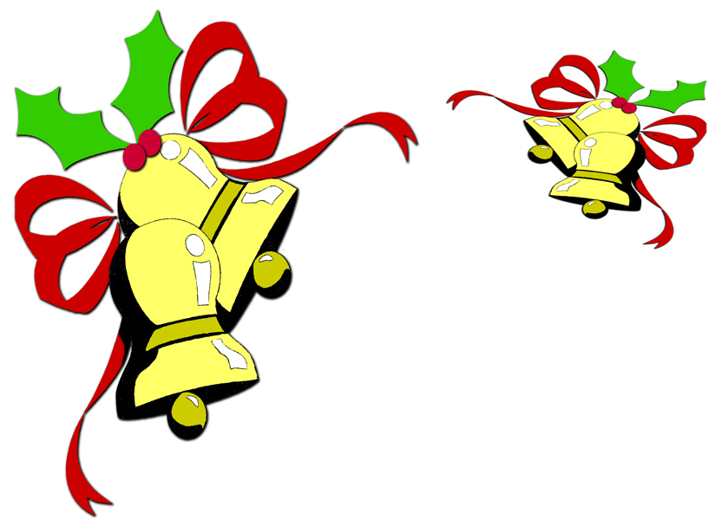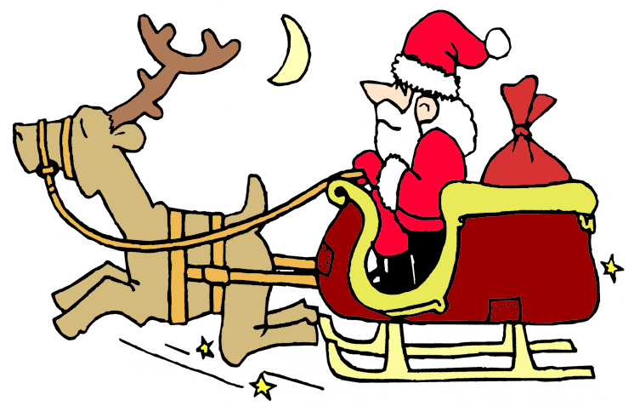

Indexers Are The Genealogist’s Best Friends

Over 1,000,000 Names Indexed

HSGS Web Site. <www.rootsweb.com/~usgenweb/mi/iosco/3501hsgs.htm> is the address for our HSGS's indexes on the Internet. The search engine for this site, or all of Michigan or any of the other Michigan’s counties is www.rootsweb.com/~usgenweb/mi/search.htm. We currently have (Nov 30 2005) 837 indexes, 22,896 printed pages, and 1,022,630 names indexed. All these files are on HSGS’s CD, but only 93% are on the web site (does not include new indexes within the last month, draft indexes not yet finished, & a some random data corrections). The status of our master indexes is as follows:

Master Index Status | Dec | Jan | Feb | Mar | Apr | May | Jun | Jul | Aug | Sep | Oct | Nov
On the web, current date | 627 | 648 | 655 | 665 | 675 | 684 | 689 | 696 | 696 | 704 | 709 | 717
On the web, outdated date | 49 | 49 | 49 | 49 | 49 | 51 | 52 | 52 | 52 | 53 | 53 | 53
New, not yet sent to web | 22 | 6 | 11 | 11 | 11 | 6 | 7 | 4 | 9 | 5 | 8 | 16
Future, being edited | 13 | 15 | 14 | 14 | 14 | 13 | 13 | 13 | 13 | 14 | 14 | 14
Future, partially keypunched | 31 | 31 | 29 | 29 | 29 | 36 | 38 | 38 | 37 | 37 | 36 | 37
Totals | 742 | 749 | 758 | 768 | 778 | 790 | 799 | 803 | 807 | 813 | 820 | 837

HSGS member Dan Stock HSGS’s Web Master is placing our indexes directly on our USGENWEB web site.

New Indexes Added This Month:
- 63rdFighterInterceptorSquardron OfficerRoster1952, by Alonzo J Sherman of Oscoda MI.
- 63rdFighterInterceptorSquardronTelephoneDirectory1952, by Alonzo J Sherman of Oscoda MI.
- 84thAirBaseSquadronOfficerRoster1952, by Alonzo J Sherman of Oscoda MI.
- Wurtsmith Air Force Base 1982, by Alonzo J Sherman.
- Medal Of Honor Recipients 1863-1978 (Michigan), by Alonzo J Sherman.
- 379th Bombardment Wing 1958, by Alonzo J Sherman.
- Change of Command & Retirement 1984, by Alonzo J Sherman
- Combat Crew- 379th Bombardment Wing 1942-1974, by Alonzo J Sherman.
- Tuskegee Airmen 1983, by Alonzo J Sherman
- WAFB Dedication Booklet: 1953, by Alonzo J Sherman.
- Tawas Herald 1916 Sep & Oct, by Joan Doerr of Ellicott City MD.
- The Warbler (WAFB OWC) Nov 1963, Nov 1987, Feb 1991 & Feb 1992, by Barbara Johnson of Eden Prairie MN.

New Books Added to HSGS’s Library This Month:
- Grandpa Wood, donated by Jim Farrand of National City MI.
- Historic Hastings 1867-1967 (Ontario Canada), by Gerald E Boyce on behalf of the Hastings County Historical Society, published by the Hasting County Council, ©1967. Donated by Iosco-Arenac District Library.
- Empire Builders: How Michigan Entrepreneurs Helped Make America Great, by Burton W Folsom Jr, ©1988. Donated by the Robert J Parks Public Library.

HSGS’s Treasurers Report (11/30/2005). Savings $1,109.87, Checking $1,178.71, cash $0.14 = Total $2,288.72

Canadian Census. The 1911 census is on line at www.genealogy.gc.ca/06/06_e.html. (Flint Genealogical Newsletter v28n9p4, Dec 2005).

Michigan Civil War Principals & Substitutes Index. The Union established a draft with the 1963 Enrolment Act. Section 13 of this act allowed draftees to avoid service by paying a $300 commutation fee or by hiring a substitute. The commutation rule as abandoned the next year but the substitution rule lasted for the entire war. This is a new file indexed by volunteers at the State Archives, for more in see: www.michigan.gov/hal/0,1607,7-160-17445_19273_19313-125416--,00.html. (Flint Genealogical Newsletter v28n9p3, Dec 2005).

Castle Garden. 10 million immigrates came though Castle Garden NY between 1830-1892, prior to opening of Ellis Island in 1892. See www.castlegarden.org.

Life Story Recording Modernizes Oral Biographies. For more info visit www.LifeStoryRecording.Com or call 866-255-1642. (From a brochure to HSGS).

Did You Know Everton Offers Free, Colorful Forms Online? Print or download a Pedigree Chart, used to record direct lineage, or a Family Group Sheet, used to record family information. These sheets are designed to help you easily record your family information. An important note: to make the forms last, they need to be printed on archival quality paper, and stored in a sheet protector in a cool, dry location. Go to www.everton.com and see what other discoveries are available for free in the Everton Online Library. Check out the Online Library subscription while you are there, and see the resources at your fingertips once you subscribe. Then call 1.800.443.6325 or subscribe online to get your full year’s subscription to Everton’s Genealogical Helper magazine with full access to an amazing collection of newspapers, archives, searchable databases and more! Full details are available at http://www.everton.com/library/. (Everton’s Newsline, Nov 18).

Free Copies Of Everton’s Genealogical Helper For Your Conference/Workshop. Everton Publishers will gladly donate copies of Everton’s Genealogical Helper for the attendees at your local, regional, or national genealogical conferences or workshops. We need to be notified at least one month prior to the event. Call or email Miste at 435 752-6022; miste@everton.com with your request. Be sure to give us a complete shipping address (no PO boxes), contact telephone #/email, and the number of attendees. (Everton’s Newsline Nov 11 2005). (Dick Eastman Online Newsletter, November 26, 2005).

Beware Of "Your Family's Coat Of Arms" Scams! As the Christmas shopping season is upon us, perhaps it is time to remind people that there is no such thing as a "family" coat of arms. Sorry folks, that stuff is totally bogus. Don't waste your money! The people selling that stuff are flim-flam artists. Ask them for documentation that the coat of arms they sell is, in fact, authorized for everyone with the same last name as your own. They won't be able to do so because that is not how coats of arms are issued.

Coats of arms are part of a system of heraldry or the display of armorial designs that goes back to the Middle Ages. The United States has no system of coats of arms. Awarding of coats of arms is done only in the British Isles, the former British Commonwealth nations, Europe, and a few countries in Asia.

In the British Isles, the former British Commonwealth nations and most western European countries, coats of arms are only awarded to individuals. To be sure, another person (usually the oldest son) may be able to obtain permission to display the same coat of arms if he applies for it after the death of the original holder. Therefore, if you are the oldest son of the oldest son of the oldest son of the oldest son of the person originally awarded the coat of arms, you might be allowed to display the same coat of arms, after you have applied for the right to display it.

A written application is required, and only one person is approved. Anyone else wanting to display the same coat of arms must wait for the death of the present holder and then apply himself. The actual rules for the use and display of coats of arms are a bit more complex than what I want to describe here, but suffice it to say that 99.9% of the purveyors of coat of arms reproductions ignore all those rules.

NOTE: If you have a certificate from the herald authority of the country involved, then you do have the authority to display the coat of arms. However, if you have such permission, I suspect you probably already know a great deal about this subject. For those without written authorization, I will caution you that displaying an unauthorized coat of arms as your own is a form of impersonation.
NOTE #2: There are some variations of these rules in a few European countries. The Netherlands has two parallel systems for coat of arms. Families of the nobility follow the above rules while medieval families of the merchant class developed a different system that can be passed from father to son without paperwork. Some eastern European families use a coat of arms system with somewhat different rules. However, the only place I know of that allows for coats of arms to be used by everyone of a certain surname is Japan. If you are a direct all-male descendant of a Samurai warrior, you can ignore this article.

Because of the extra protection offered by credit card companies, always make your online and offline purchases by credit card. Do not use cash, checks, money orders, or debit cards for online purchases; you will not enjoy the same level of protection as that provided by credit cards. Despite the "old wives' tales" that float around, credit cards are always the safest method of sending payments, both online and offline. (Debit cards are not true credit cards and may or may not have fraud protection. Check with your issuing bank for details.)
For more information about the proper use of coats of arms and other armorial designs, check out the following web sites:
The College of Arms is the official repository of the coats of arms and pedigrees of English, Welsh, Northern Irish and Commonwealth families and their descendants: http://www.college-of-arms.gov.uk
The Heraldry Society exists to increase and extend interest in and knowledge of heraldry, armory, chivalry, genealogy and allied subjects: http://www.theheraldrysociety.com
The Heraldry Society of Scotland promotes the study of heraldry and encourages its correct use in Scotland and overseas: http://www.heraldry-scotland.co.uk/
The Royal Heraldry Society of Canada or RHSC and its branches encourages, educates, and promotes the art and science of heraldry: http://www.heraldry.ca
I do have one word of advice: if your relative buys you a Christmas present that includes the "family's coat of arms," I suggest that you smile graciously and accept the gift. Don't break out laughing until you return to the privacy of your own home. After all, there is no sense in making fun of someone else's innocence. (Dick Eastman Newsletter Nov 26 2005).

Australian Census Information to be Locked for 99 Years. Proposed new laws in Australia will keep all future census records under lock and key for 99 years. Parliamentary Secretary to the Treasurer Chris Pearce says the information will be strictly protected over the period, even banning courts and tribunals from accessing the information. "The public can accordingly be confident this picture of Australia will, in a very real sense, be preserved in a time capsule, available after 99 years has expired, as a legacy for our descendants into the future," Mr. Pearce told parliament. He said the proposed laws would build on the experience of the 2001 census, where more than half the population opted to have their information archived. (Dick Eastman Newsletter Nov 4 2005).

Gene Found In Black Death Descendants Stops HIV. According to research done by Dr. Stephen O'Brien, a mutated gene known as delta 32, which is found in Black Death survivor descendants, stops HIV in its tracks. The discovery was made by combining the sciences of DNA and genealogy. (Dick Eastman Newsletter Nov 5 2005).

Copyright Myths. Here are a few old wives' tales that I have heard recently:
- "I found the information on the Internet, so I have a right to copy it and use it on my own Web site."
- "Everything on the Web is free."
- "If I attribute where I found it, I can copy it and use it."
- "I can use that information as long as I don't charge for it."
- "The original records are public domain, so I can legally copy that information from a book, CD-ROM or
Web site."
- "The information was published by a non-profit organization, so I can legally republish it."
- "The information was not labeled as copyright protected, so I can use it."
- "You cannot copyright facts, and I am only publishing the facts."
- "Well, everybody does it!"
One problem: all of the above reasons are wrong. If you republish information without permission, you may find yourself receiving an unpleasant letter from a law firm.

Under U.S. copyright laws, all content today is copyrighted unless otherwise specified.

It makes no difference if the information comes from the New York Times' Web site, from a non-profit society's site, or from cousin Lew's personal Web site: you cannot copy and re-use that information without permission. It also makes absolutely no difference whether you charge money or not. Likewise, attributing the source makes no difference. Publishing someone else's material without permission is illegal.
For further details, you might want to refer to the following:
U.S. Copyright and Genealogy by Mike Goad: http://stellar-one.com/copyrightgenealogy/
Public Domain Information for Genealogists by Marji Hazen: http://www.bright.net/~webmarji/GenPD/
Responsible Genealogy: Copyrights, Privileges and Responsibilities by Diana L. Smith: http://members.aol.com/dianahome/column14.htm
Mistake or Misdemeanor - Staying Legal with Internet Copyrights by Rhonda R. McClure: http://www.thegenealogist.com/art3.htm
Horror on the Web by Myra Vanderpool Gormley: click here
Copyrights & Wrongs by Mark Howells: http://www.oz.net/~markhow/writing/copy.htm

(From Dick Eastman’s Online Newsletter, Nov 12 2005)

HSGS Records ready to be keypunched (We need some new indexers to help index these records, we have over a half million records be indexed): See August Newsletter for the list of files.

HSGS’s Jobs List. It is necessary for other HSGS members to step forward and accomplish these jobs. The members currently working in the library are busy serving the patrons research needs, and do not have time left for this work. Note some of these jobs can be done in you home wherever you live, and some can only be done in your home only if you live in the local area, and some need to be done in the library. Contact Mr Sherman if you can help at shermanaj@hotmail.com or 989-739-3650.

Job Name | Hrs | Location | Special Skills
Letter 40 Pioneer Society Book spines | 2-4hrs | Library | Gelink Pen (HSGS has)
New Labels on Gazette Microfilm cans/boxes, that include roll # & date span. 36 cans/boxes. | 2 days | Library | Computer, label program
Project Officer for Poor Farm Cemetery | 1 wk/yr | Spartan Rd, Tawas City | Lawn mowing/trimming
Proper shelving of books, check for | 1 wkly | Library | None
Time Report- Help design & maintain HSGS Time Report (For stats for future grants etc) | 4 mo | Home (anywhere) | Computer, Excel or Word (tables), & Email

TRAINING AVAILABLE (One Time Events):

Year/Mo/Day | Description/Location/Contact
2005/12/03  Sat | Abrams Genealogy Series. Finding Your Irish Ancestors. At Library of Michigan in Lansing MI. Contact 517-373-1300.
2006/01/22  Sun | Looking At Maps: Historic Michigan & Great Lakes Cartography, Clements Library UofM. For in contact www.hvcn.org/info/gswc.
2006/02/10-11  Fri-Sat | Genealogy & Family Heritage Jamboree, Dixie Convention Center in StGeorge Utah. Sponsored by My Ancestors. See www.myansterorsfound.com.

OTHER TRAINING:

- Individual Training Schedule (Recurring), see p10 of February 2005 Newsletter.

- Individual Training Schedule (By Appointment), see p11 of February 2005 Newsletter.

- Training Courses Online, see p11 of February 2005 Newsletter.

SOME USEFUL GENEALOGICAL INTERNET ADDRESSES:

See June 2005 Newsletter. Prepared by Judy Sheldon. Please notify us at judesheldon@yahoo.com of any broken links or links you think should be added to this list.

INDEXERS ROLL OF HONOR

See August 2005 Newsletter

ANCESTRY LIBRARY EDITION

See August 2005 Newsletter

HURON SHORES GENEALOGICALSOCIETY ACTIVE MEMBERS.

C/o Robert J Parks Public Library, 6010 N Skeel Ave, Oscoda MI 48750, and Phone 989-739-9581. The Library is open Mon, Fri & Sat 9:00am-5:00pm & Tue-Wed-Thur 9am-8:00pm (HSGS member available 9:00am-3:00pm Sat). HSGS’s meetings are 7-8pm the 3rd Thursday of Jan, Apr, and Jul & Oct in the Oscoda Library (This may change in 2005, so call before coming). Officers, project leaders & active indexers are listed below:

Name | Current Projects | Phone & E-mail
Beuthin, Rancy | Indexing Pioneer Society | 231-825-9773 <arby@speed2u.net>
Birnbaum, Charles | Iosco County Death Indexes, News Herald Index, Saginaw News Obits e | 989-362-5994 <Birnbaumcr@hotmail.com>
Brewer, Karen | Transcribing various cemetery records | 810-749-2830 <kfolly@earthlink.net>
Burns, Samantha | Transcribing various records | 989-739-7431 <none>
Carraway, Marianne | Hale Year Books | 989-739-9569 <mcarraway@charter.mi.net>
Daley, Lawrence | Hale Yearbook 1901-2002 | 248-253-7472 <daleymart@msn.com>
Dingus, Ginger Metcalf | Secretary, Transcribing various records | 989-362-4706 <gingey326@hotmail.com>
Doerr, Joan | Tawas Herald Newspaper Index | 410-461-1407 <JoanDoerr@hotmail.com>
Donaldson, James | Assists, His Oscoda Press Collection | 313-835-2440 <ab6943@wayne.edu>
Dressel, David | Transcribing various records | 480-838-4744 <ddressel@mail.cyberspeedway.net>
Durkin, Thomas | Transcribing various records | 904-273-8053 <TomPatDurkin@Yahoo.com>
Farrand, Jim | Transcribing various records | 989-469-2308 <farrand@chartermi.net>
Foust, Ruby | Transcribing various records | 352-799-2604 <lfoust@tampabay.rr.com>
Groff, Jan | Transcribing various records | 989-362-6777 <jalynn1G@yahoo.com>
Huebner, Christine | Transcribing various records | 989-362-7423 <delnorte@voyager.net>
Johnson, Barbara | Transcribing various records | 952-934-7797, <bjohnson@edenpr.org>
Klenow, Rosemary | Vice-President | 989-362-5425 <klenowr@alpena.cc.mi.us>
Kruszka, Anne Percival | Iosco County Gazette Index | 734-261-6416 <ackruszka@wmconnect.com>
Lascon, Diana | Transcribing various records | 510-487-5729 <dlacson_2000@yahoo.com>
Petee, Bonnie | Transcribing various records | 810-636-9348 <gypsy2@chartermi.net>
Schoonover, Duane | Transcribing various records | 989-820-0078 <duane881@hotmail.com>
Selbrede, Jennifer | Tawas Herald Newspaper Index | 760-373-2204 <jen@postoffice.ccis.com>
Sheldon, Judy | Treasurer | 989-739-5497 <judesheldon@yahoo.com>
Sherman, Alonzo | Librarian/Publications | 989-739-3650 <shermanaj@hotmail.com>
Stevens, Grace | School Yearbooks Index | 616-349-7840 <GraceACE@aol.com>
Stock, Dan | Putting indexes on the Web Site | 989-739-4239 <etts95@yahoo.com>
Stonehouse, Naomi | President | 989-362-8187 <alvene2000@yahoo.com>
Summers. Leona | Oscoda Press Index | 989-724-6510 <none>
Whitford, Sandy | Indexing HS Yearbooks | 989-362-3679 <wumpw@yahoo.com>
Yorkell-Parker, Sandra | Indexing Pioneer Society | ???-???-???? <syparker@nidlink.com>

Huron Shores Genealogical Society
C/o Robert J Parks Public Library

6010 N Skeel Ave
Oscoda MI 48750

