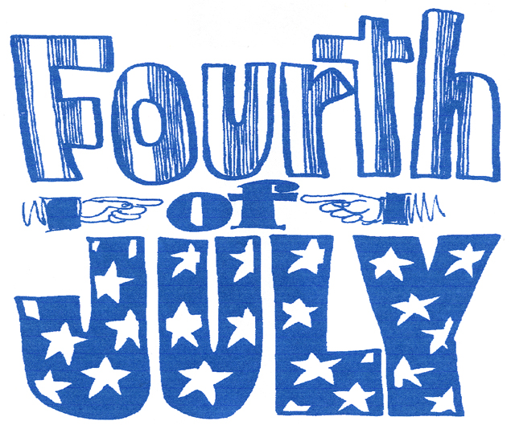

Indexers Are The Genealogist’s Best Friends

HSGS Web Site. <www.rootsweb.com/~usgenweb/mi/iosco/3501hsgs.htm> is the address for our HSGS's indexes on the Internet. The search engine for this site, or all of Michigan or any of the other Michigan’s counties is www.rootsweb.com/~usgenweb/mi/search.htm. We currently have (June 30 2006) 935 indexes, 24,209 printed pages, and 1,075,440 names indexed. All these files are on HSGS’s master file & the CD we sell, but only about 94% are on the web site (does not include new indexes within the last month, draft indexes not yet finished, & a some random data corrections). The status of our master indexes & CD follows:

Master Index Status | Jun | Jul | Aug | Sep | Oct | Nov | Dec | Jan | Feb | Mar | APR | May | Jun
On the web, current | 689 | 696 | 696 | 704 | 709 | 717 | 735 | 742 | 768 | 785 | 811 | 834 | 830
On the web, outdated | 52 | 52 | 52 | 53 | 53 | 53 | 52 | 51 | 54 | 54 | 54 | 49 | 55
New, not yet sent to web | 7 | 4 | 9 | 5 | 8 | 16 | 7 | 29 | 16 | 22 | 17 | 3 | 6
Future, being edited | 13 | 13 | 13 | 14 | 14 | 14 | 14 | 21 | 21 | 14 | 6 | 6 | 8
Future, partially keypunched | 38 | 38 | 37 | 37 | 36 | 37 | 37 | 37 | 36 | 36 | 36 | 36 | 36
Totals | 799 | 803 | 807 | 813 | 820 | 837 | 849 | 880 | 895 | 911 | 924 | 928 | 935

HSGS member Dan Stock HSGS’s Web Master is placing our indexes directly on our USGENWEB web site.

New Indexes Added This Month:
- Index to Messages of the Governors 1961-2002. By Alonzo J Sherman of Oscoda MI.
- Index To Barkman Outfitting Company’s Day Book 1949-1950. By Alonzo J Sherman.
- Index to WAFB Officer’s Wives Club Warbler: 1966 (03), 1966 (04), 1966 (05), 1966 (06), and 1972 (10). By Jim Farrand of National City MI.

New Documents Added to HSGS’s Library This Month:
- Barkman Outfitting Company’s Day Books: 1940-1941, 1941-1942 & 1945-1946. Donated by James Donaldson of Detroit MI..

HSGS’s Treasurers Report (June 30 2006). Savings $1,134.71, Checking $584.77, cash $20.84, checks $36.20 = Sub-Total $1,776.52. Plus $249.98 cash card credit at Staples = Total of $2,026.50.

LDS & Michigan State Archives Agreement. An agreement has been reached between the LDS and the State Archives which allows LDS to place the Archives materials online at the LDS site, but it will be for viewing only. The Archives will sell copies of the material. The planned starting date is the fall of 2006, with the Naturalization records going on first, and the Michigan Census records going about a year later. (Saginaw Gen Soc Newsletter v28n9p436).

Social Security Applications. There is a movement underway to reduce access to federal government records because of security issues. Best get your ancestors Social Security applications soon. (Saginaw Gen Soc Newsletter v28n9p536).

Genealogy Information Is A Hot Commodity. Someone has been taking magazines and newsletters that are published by various genealogical societies and putting them on CDs and selling them on eBay. If you come across any of those alert eBay and they will remove them. (Northville Gen Soc April/May 2006, via the Saginaw Gen Soc Newsletter v28n9p536).

Massachusetts Bill. A bill seeks to close all Massachusetts Public Records and their indexes to the Public. (eNews v8n26hn275 June 21 2006).

The National Archives. The archives were closed recently due to flooding. However there was no damage to their records. (eNews v8n26hn277 June 28 2006).

Michigan Historical Museum, Lansing MI. A new special exhibit titled “Michigan’s Family Album” opens August 5 2006. This a selection from one of the largest private collections of Michigan photographs. The photographs in the exhibit resembles a family photo album of Michigan life from 1860s to the 1920s. There are more than 2,000 daguerreotypes, tintypes, stereo views, cabinet cards and large-format photos. There will also be a special display of postcards honoring every county in the state of Michigan. (The Insider, v6n1-2, Spring/Summer 2006).

Censuses. All 140 years of US Censuses (1790-1930) images and indexes are now on the internet at Ancestry.com.

INDEXERS ROLL OF HONOR

See January 2006 Newsletter. An update will be included in next month’s newsletter.

TRAINING AVAILABLE (One Time Events):

Year/Mo/Day | Description/Location/Contact
2006/07/21-21  Fri-Sat | Explore Your Roots, Discover Your History: 2006 Abrams Genealogy Seminar. Call 517-373-1300 or email librarian@michigan.gov.
2006/08/30-09/06  Wed-Wed | Federation of Genealogical Societies presents Birthplace of American Genealogy, at the Hynes Convention Center, Boston MA. Contact fgs-office@fgs.org.
2006/10/14  Sat | Michigan Gen Society Seminar at the Library of Michigan. Details at their web site www.rootsweb.com/mimgc.
2006/11/11-18  Sat-Sat | Genealogy Conference & Cruise, Mexican Riviera, sponsored by Wholly Genes Software. Info www.whollygenes.com/crusie.htm.
2007/01/08-12  Mon-Fri | Salt Lake Institute of Genealogy. Contact www.infouga.org.

OTHER TRAINING:

- Individual Training Schedule (Recurring), see p10 of February 2005 Newsletter.

- Individual Training Schedule (By Appointment), see p11 of February 2005 Newsletter.

- Training Courses Online, see p11 of February 2005 Newsletter.

ANCESTRY LIBRARY EDITION

See August 2005 Newsletter.

SOME USEFUL GENEALOGICAL INTERNET ADDRESSES:

See June 2005 Newsletter. Prepared by Judy Sheldon. Please notify us at judesheldon@yahoo.com of any broken links or links you think should be added to this list. If you have any pdates pleas let us know as we will publish an updated list in the nex few months.

HURON SHORES GENEALOGICALSOCIETY ACTIVE MEMBERS.

C/o Robert J Parks Public Library, 6010 N Skeel Ave, Oscoda MI 48750, and Phone 989-739-9581. The Library is open Mon, Fri & Sat 9:00am-5:00pm & Tue-Wed-Thur 9am-8:00pm (HSGS member available by chance or appointment). HSGS meetings are 6-7pm the 3rd Wednesday of Jan, Apr, and Jul & Oct in the Iosco County Historical Museum, 405 W Bay St (US-23), East Tawas MI. Officers, active project leaders, and indexers are listed below:

Name | Current Projects | Phone & E-mail
Birnbaum, Charles | Iosco County Death Indexes, News Herald Index, Saginaw News Obits | 989-362-5994 <Birnbaumcr@hotmail.com>
Carraway, Marianne | Hale Year Books | 989-739-9569 <mcarraway@charter.mi.net>
Daley, Lawrence | Hale Yearbook 1901-2002 | 248-253-7472 <daleymart@msn.com>
Daniels, Lugene | Burleigh Twp Farming | 989-756-3852
Doerr, Joan | Tawas Herald Newspaper Index | 410-461-1407 <JoanDoerr@hotmail.com>
Donaldson, James | Assists, His Oscoda Press Collection | 313-835-2440 <ab6943@wayne.edu>
Dressel, David | Transcribing various records | 480-838-4744 <ddressel@mail.cyberspeedway.net>
Durkin, Thomas | Transcribing various records | 904-273-8053 <TomPatDurkin@Yahoo.com>
Farrand, Jim | Transcribing the Warblers | 989-469-2308 <farrand@chartermi.net>
Johnson, Barbara | Transcribing various records | 952-934-7797, <bjohnson@edenpr.org>
Petee, Bonnie | Transcribing various records | 810-636-9348 <gypsy2@chartermi.net>
Sheldon, Judy | Treasurer | 989-739-5497 <judesheldon@yahoo.com>
Sherman, Alonzo | Librarian/Publications. Barkman Outfitter’s Day Book Indexes. | 989-739-3650 <shermanaj@hotmail.com>
Stock, Dan | Putting indexes on the Web Site | 989-739-4239 <etts95@yahoo.com>
Stonehouse, Naomi | President | 989-362-8187 <alvene2000@yahoo.com>
Summers. Leona | Oscoda Press Index | 989-724-6510 <none>

HISTORY OF THE HURON SHORES GENEALOGICAL SOCIETY

See March 2006 Newsletter.

MICHIGAN MANUALS FOR SALE

Send your check payable to the Iosco County Historical Society, 405 W Bay St (US-23), East Tawas MI 48730, 989-362-8911.

Year | Condition | Price
1897-1898 | Poor, Spin torn | $25
1899 | Fair | $35
1919 | Good | $20
1921 | Fair | $15
1949 | Good | $15
1951-1952 | Good | $15
1953-1954 | Good | $15
1957-1958 | Good | $15
1959-1960 | Good | $15
1963-1964 | Good | $15
1967-1968 | Good | $15
1969-1970 | Good | $15
1971-1972 | G00d | $15
1973-1974 | Good | $15



