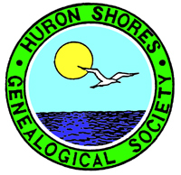
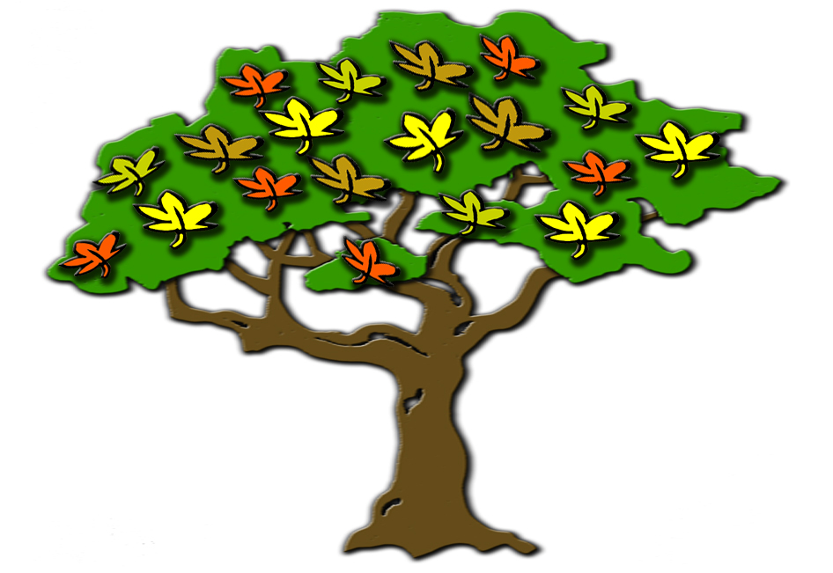



FLASH: HSGS's training program will be held at the Parks Library Saturday October 14th at Noon to 4pm.

Indexers Are The Genealogist’s Best Friends

HSGS Web Site. <www.rootsweb.com/~usgenweb/mi/iosco/3501hsgs.htm> is the address for our HSGS's indexes on the Internet. The search engine for this site, or all of Michigan or any of the other Michigan’s counties is www.rootsweb.com/~usgenweb/mi/search.htm. We currently have (August 31 2006) 963 indexes, 24,531 printed pages, and 1,089,738 names indexed. All these files are on HSGS’s master file & the CD we sell, but only about 94% are on the web site (does not include new indexes within the last month, draft indexes not yet finished, & a some random data corrections). The status of our master indexes & CD follows:

Master Index Status | Sep | Oct | Nov | Dec | Jan | Feb | Mar | Apr | May | Jun | Jul | Aug
On the web, current | 704 | 709 | 717 | 735 | 742 | 768 | 785 | 811 | 834 | 830 | 835 | 849
On the web, outdated | 53 | 53 | 53 | 52 | 51 | 54 | 54 | 54 | 49 | 55 | 54 | 55
New, not yet sent to web | 5 | 8 | 16 | 7 | 29 | 16 | 22 | 17 | 3 | 6 | 14 | 16
Future, being edited | 14 | 14 | 14 | 14 | 21 | 21 | 14 | 6 | 6 | 8 | 7 | 7
Future, partially keypunched | 37 | 36 | 37 | 37 | 37 | 36 | 36 | 36 | 36 | 36 | 36 | 36
Totals | 813 | 820 | 837 | 849 | 880 | 895 | 911 | 924 | 928 | 935 | 946 | 963

HSGS member Dan Stock HSGS’s Web Master is placing our indexes directly on our USGENWEB web site.

New Indexes Added This Month:

- Tawas Bay Players, August 2006. By Alonzo J Sherman of Oscoda MI.
- Tawas Herald, updated August 1909 (Added issue 08/20/1909). By Joan Doerr of Endicott City MD.
- Tawas Herald, May, June, July, Aug, Sep, Oct & Nov 1910. By Joan Doerr.
- The Warbler Magazine, Oct, Nov & Dec 1961, and Jan, Feb, Mar, Apr & May 1962. By Jim Farrand of National City MI.

New Documents Added to HSGS’s Library This Month:
- Families, Ontario Genealogical Society, Aug & Nov 2004, and Feb, May & Aug 2006. By Rodger Miller of Ontario.

HSGS’s Treasurers Report (July 28 2006). Savings $1,138.22, Checking $709.69, cash $16.28, = Sub-Total $1,864.19: Plus $249.98 cash card credit at Staples = Total of $2,114.17.

The Iosco County Historical Museum’s New History Book. An August 16 2006 letter from them gave apologizes for the delays, and indicates they have received the final proofs from the publisher. They are hopefull the book will be published in September 2006, or soon thereafter.

Archives of Michigan. New hours are 9am-1pm Mon & Thur, and 1pm-5pm Tue, Wed & Fri. (MI Gen Council Newsletter, Summer 2008 page 1).

To Located New & Used books. www.abebooks.com or www.bookfinder.com. (Kalamazoo Valley Heritage p129v30n9 June 2006).

Castle Garden. America’s first immigration center offers a free data-base for 10 million immigrates from 1830-1892. (Western MI Gen Soc Newsletter, Fall 2006).

Michigan Genealogist. This is a free Quarterly newsletter of the Dept of History, Arts & Libraries (HAL). Three issues have be published to date. See web site for details: www.michigan.gov/hal/0.1607,7-160-17449_18635_38463---00.html (Note blank space in this address are a _). (The Downriver Seeker v26n3 Aug 2006).

The New Google Video Search. Google.com has now added a VIDEO SEARCH: http://genealogyblog.com/computer-tech/search-engines/the-new-google-video-search-5443. (Everton Newsline Aug 14 2006).

Early California Mission Register Vital Records Now Online. The Huntington Library in San Marino, California has just launched a major new database. The searchable database makes accessible about 101,000 baptisms, 28,000 marriages and 71,000 burials performed in California between 1769 and 1850. For more information, see: http://genealogyblog.com/united-states-research/california/early-california-mission-register-vital-records-now-online-5436. (Everton Newsline Aug 14 2006).

Homeland Security Says Fix Your Windows. In a rare alert, the U.S. Department of Homeland Security has urged WINDOWS users to plug a potential worm hole in the Microsoft operating system. For more information, see: http://genealogyblog.com/computer-tech/homeland-security-says-fix-your-windows-5434. (Everton Newsline Aug 14 2006).

Worldcat Search From OCLC Online With Free Access. A new WorldCat Search is now online and in the clear. Although a simple search engine, it is one of the most powerful I have ever used. Look for books worldwide about your family or places of interest. For more information, see: http://genealogyblog.com/libraries/worldcat-search-from-oclc-online-with-free-access-5432. (Everton Newsline Aug 14 2006).

The New Church Of England (Anglican) Genealogy Website. Having realized the need by genealogists for information about their records, the Anglican Church has created a new website. For more information, see: http://genealogyblog.com/british-research/the-new-church-of-england-anglican-genealogy-website-5428. (Everton Newsline Aug 14 2006).

Google To Digitize Three Million Books At The University Of California. Google will be scanning and digitizing millions of books from more than 100 libraries across 10 campuses of the University of California and making them fully searchable online using Google Book Search. For more information, see: http://genealogyblog.com/libraries/google-to-digitize-3-million-books-at-the-university-of-california-5424. (Everton Newsline Aug 14 2006).

Familysearch To Be Retooled Adding Scanned Images And Indexed Maps. Huge changes are about to take place on the FamilySearch website For more information, see: http://genealogyblog.com/maps/familysearch-bigger-better-and-really-cool-5423. (Everton Newsline Aug 14 2006).

Ancestry.Com Posts Mortality Schedule 1850-1880 Digitized Images. Ancestry.com has just posted many mortality schedules, previously only available in unindexed form, and on microfilm. Although an ongoing project, many schedules are now indexed and online. For more information, see: http://genealogyblog.com/census-us/ancestrycom-posts-mortality-schedule-1850-1880-digitized-images-5418. (Everton Newsline Aug 14 2006).

Lutheran Genealogy. If you are Lutheran or you have Lutheran ancestry, you really should check out the Lutheran Genealogy Exchange. For more information, see: http://genealogyblog.com/religions/lutheran/genealogy-for-lutherans-3616. (Everton Newsline Aug 14 2006).

The Domesday Book Goes Online At The British National Archives. The Domesday Book is now available online. In the winter of 1085, William the Conqueror commissioned a great survey to find out the resources and taxable value of all the boroughs and manors of England. That record still exists today in the form of the Domesday Book. This book is complete with names from the eleventh-century. Read more about the digital Domesday Book at: http://genealogyblog.com/british-research/the-domesday-book-goes-online-at-the-british-national-archives-site-5409. (Everton Newsline Aug 7).

A Serious Problem With The Transcription Of The Encyclopedia Of Quaker Genealogy- Known As Hinshaw. It seems that the transcription of Hinshaw, which genealogists have been using for years, may have some serious problems. It has come to light that the transcriber of the work had genealogical charts to go by, coloring and sometimes changing the data when it did not agree with the charts. Whoops... This could be a major problem. Read more about the Hinshaw problems at: http://genealogyblog.com/united-states-research/new-york/a-serious-problem-with-the-transcription-of-hinshaw-5406. (Everton Newsline Aug 7).

Old Yearbooks Online. Although by no means all inclusive, the Old Yearbooks website has a lot of digitized yearbooks on their site - and they link to many others. I have found the site useful in locating yearbooks I would never find otherwise. For more information, see: http://genealogyblog.com/family-tree-connection/old-yearbooks-online-4502. (Everton Newsline Aug 7).

Over 5000 Freely Available Books Digitized And Indexed On BYU Servers. The announcement went out last fall, but I find that many folks still do not know that over 5000 family histories are available online for free right now. For more information, see: http://genealogyblog.com/family-history-library/5000-family-history-books-now-online-and-searchable-on-byus-servers-4457. (Everton Newsline Aug 7).

Historic United States Post Offices. Post offices have come and gone over the years, just as the communities that supported them have also disappeared. Jim Forte has a terrific postal history website that includes 186,056 listings of U.S. post offices. For more information, see: http://genealogyblog.com/general/united-states-post-offices-5117. (Everton Newsline Aug 7).

Historical Maps Online (http://images.library.uiuc.edu/projects/maps/). Historical Maps Online is a collaborative project between the University of Illinois Library and the University of Illinois Press. The purpose of the project is to publish electronically the images of maps charting the last 400 years of historical development in Illinois and the Northwest Territory. You can browse through the maps by topic areas or search through the collections using the collections search function.
Historical Maps Online is a collaborative project between the University of Illinois Library and the University of Illinois Press. The purpose of the project is to publish electronically the images of maps charting the last 400 years of historical development in Illinois and the Northwest Territory. You can browse through the maps by topic areas or search through. (NEHSGS eNews 284 Aug 16 2006).

The Allen County Public Library. The last day at our temporary location at Renaissance Square (where we have been for the last several years) will be Saturday, December 23, 2006. We will re-open at our original location with a grand celebration in a greatly expanded and wonderfully renovated library on Saturday, January 27, 2007. (Genealogy Gems #29 Ft Wayne Jul 31 2006).

INDEXERS ROLL OF HONOR

See July 2006 Newsletter.

TRAINING AVAILABLE (One Time Events):

Year/Mo/Day | Description/Location/Contact
2006/09/22-24  Fri-Sun | The Bay County Hist Soc & Museum will host the Historical Society of Michigan’s State Historical Conference. See <hsm@hsmichigan,org or 800-692-1828.
2006/09/30  Sat | “Not Far From the Tree,” (Southern & African Genealogy). Free Family History Festival at the Detroit Public Library, 5201 Woodward Ave, Detroit. For more info visit www.detroitpubliclibrary.org or 313-833-1480.
2006/10/14  Sat | Flint Genealogical Society 50th Anniversary Seminar: Exploring Ontario Genealogy With Ruth Burkholder. At Flint Public Library, 1026 Kearsely St, 10am-4:30pm. Contact 810-232-7111 Ext 6.
2006/10/14  Sat | Michigan Gen Society Seminar at the Library of Michigan. Details at their web site www.rootsweb.com/mimgc.
2006/10/21  Sat | LDS free seminar, 9am-5pm, “Tracing our Ancestors Footsteps II.” Located LDS church at 37425 Woodward Ave, Bloomfield Hills, MI. Contact Mrs Wally Schegel at Wally_Schlegel@ameritech.net.
2006/11/11-18  Sat-Sat | Genealogy Conference & Cruise, Mexican Riviera, sponsored by Wholly Genes Software. Info www.whollygenes.com/crusie.htm.
2006/11/18  Sat | Detroit Society for Genealogical Research, “The $5 Day and How We Grew.” 1:30pm at the Explorer’s Room Detroit Public Library. Info 248-541-0403 or 313-884-0039 or <cpsrch@aol.com>.
2007/01/06  Sat | Detroit Society for Genealogical Research, “Research at the Burton Historical Collections,” held at Christ Church, Cranbrook, Bloomfield Hills. Info 248-541-0403 or 313-884-0039 or <cpsrch@aol.com>.
2007/01/08-12  Mon-Fri | Salt Lake Institute of Genealogy. Contact www.infouga.org.
2007/02/10  Sat | Detroit Society for Genealogical Research, Research Trip tp Newly Renovated & Expanded Allen County Public Library, FtWayne IN. Info 248-541-0403 or 313-884-0039 or <cpsrch@aol.com>.
2007/03/10  Sat | Detroit Society for Genealogical Research, To be announced. Info 248-541-0403 or 313-884-0039 or <cpsrch@aol.com>.
2007/04/22  Sun | Detroit Society for Genealogical Research, Local History Conference, Wayne State University. Info 248-541-0403 or 313-884-0039 or <cpsrch@aol.com>.
2007/05/12  Sat | Detroit Society for Genealogical Research, Beginner’s Workshop. Info 248-541-0403 or 313-884-0039 or <cpsrch@aol.com>.
2007/08/15-18 | Federation of Genealogical Socities & Allen County Public Library will hold their conference “Meeting at the Crossroads of America”, at Grand Wayne Center, Ft Wayne IN. See <www.fgs/org/2007conf/FGS-2007.htm>.

OTHER TRAINING:

- Individual Training Schedule (Recurring), see p10 of February 2005 Newsletter.

- Individual Training Schedule (By Appointment), see p11 of February 2005 Newsletter.

- Training Courses Online, see p11 of February 2005 Newsletter.

ANCESTRY LIBRARY EDITION

See August 2005 Newsletter.

SOME USEFUL GENEALOGICAL INTERNET ADDRESSES:

See June 2005 Newsletter. Prepared by Judy Sheldon. Please notify us at judesheldon@yahoo.com of any broken links or links you think should be added to this list. If you have any updates please let us know, as we will publish an updated list in the next few months.

HURON SHORES GENEALOGICALSOCIETY ACTIVE MEMBERS.

C/o Robert J Parks Public Library, 6010 N Skeel Ave, Oscoda MI 48750, and Phone 989-739-9581. The Library is open Mon, Fri & Sat 9:00am-5:00pm & Tue-Wed-Thur 9am-8:00pm (HSGS member available by chance or appointment). HSGS meetings are 6-7pm the 3rd Wednesday of Jan, Apr, and Jul & Oct in the Iosco County Historical Museum, 405 W Bay St (US-23), East Tawas MI. Officers, active project leaders, and indexers are listed below:

Name | Current Projects | Phone & E-mail
Birnbaum, Charles | Iosco County Death Indexes, News Herald Index, Saginaw News Obits | 989-362-5994 <Birnbaumcr@hotmail.com>
Carraway, Marianne | Hale Year Books | 989-739-9569 <mcarraway@charter.mi.net>
Daley, Lawrence | Hale Yearbook 1901-2002 | 248-253-7472 <daleymart@msn.com>
Daniels, Lugene | Burleigh Twp Farming | 989-756-3852
Doerr, Joan | Tawas Herald Newspaper Index | 410-461-1407 <JoanDoerr@hotmail.com>
Donaldson, James | Assists, His Oscoda Press Collection | 313-835-2440 <ab6943@wayne.edu>
Dressel, David | Transcribing various records | 480-838-4744 <ddressel@mail.cyberspeedway.net>
Durkin, Thomas | Transcribing various records | 904-273-8053 <TomPatDurkin@Yahoo.com>
Farrand, Jim | Transcribing the Warblers | 989-469-2308 <farrand@chartermi.net>
Johnson, Barbara | Transcribing various records | 952-934-7797, <bjohnson@edenpr.org>
Petee, Bonnie | Transcribing various records | 810-636-9348 <gypsy2@chartermi.net>
Sheldon, Judy | Treasurer | 989-739-5497 <judesheldon@yahoo.com>
Sherman, Alonzo | Librarian/Publications. Barkman Outfitter’s Day Book Indexes. | 989-739-3650 <shermanaj@hotmail.com>
Stock, Dan | Putting indexes on the Web Site | 989-739-4239 <etts95@yahoo.com>
Stonehouse, Naomi | President | 989-362-8187 <alvene2000@yahoo.com>
Summers. Leona | Oscoda Press Index | 989-724-6510 <none>

HISTORY OF THE HURON SHORES GENEALOGICAL SOCIETY

See March 2006 Newsletter.

MICHIGAN MANUALS FOR SALE

Send your check payable to the Iosco County Historical Society, 405 W Bay St (US-23), East Tawas MI 48730, 989-362-8911.

Year | Condition | Price
1897-1898 | Poor, Spin torn | $25
1899 | Fair | $35
1919 | Good | $20
1921 | Fair | $15
1949 | Good | $15
1951-1952 | Good | $15
1953-1954 | Good | $15
1957-1958 | Good | $15
1959-1960 | Good | $15
1963-1964 | Good | $15
1967-1968 | Good | $15
1969-1970 | Good | $15
1971-1972 | Good | $15
1973-1974 | Good | $15

FOR-FEE-RESEARCHERS

- Iosco County Michigan:
  - Naomi Stonehouse, 111 5th Ave, Tawas City Michigan 48763, 989-362-8187, alvena2000@yahoo.com.
  - Iosco County News-Herald, 110 W State St, POB 72, East Tawas MI 48730, 989-362-3456. Reportedly published articles can be purchased for $5.00 plus postage.
- Arenac County Michigan: Arenac County Historical Society & Museum, 304 E Michigan Ave, AuGres MI 48703, 989-876-6399.
- Other Michigan Counties: Inquire at the Library of Michigan for a list of for-fee-researchers, 717 Allegan St, Box 30007, Lansing MI 48909, 517-373-1580.



