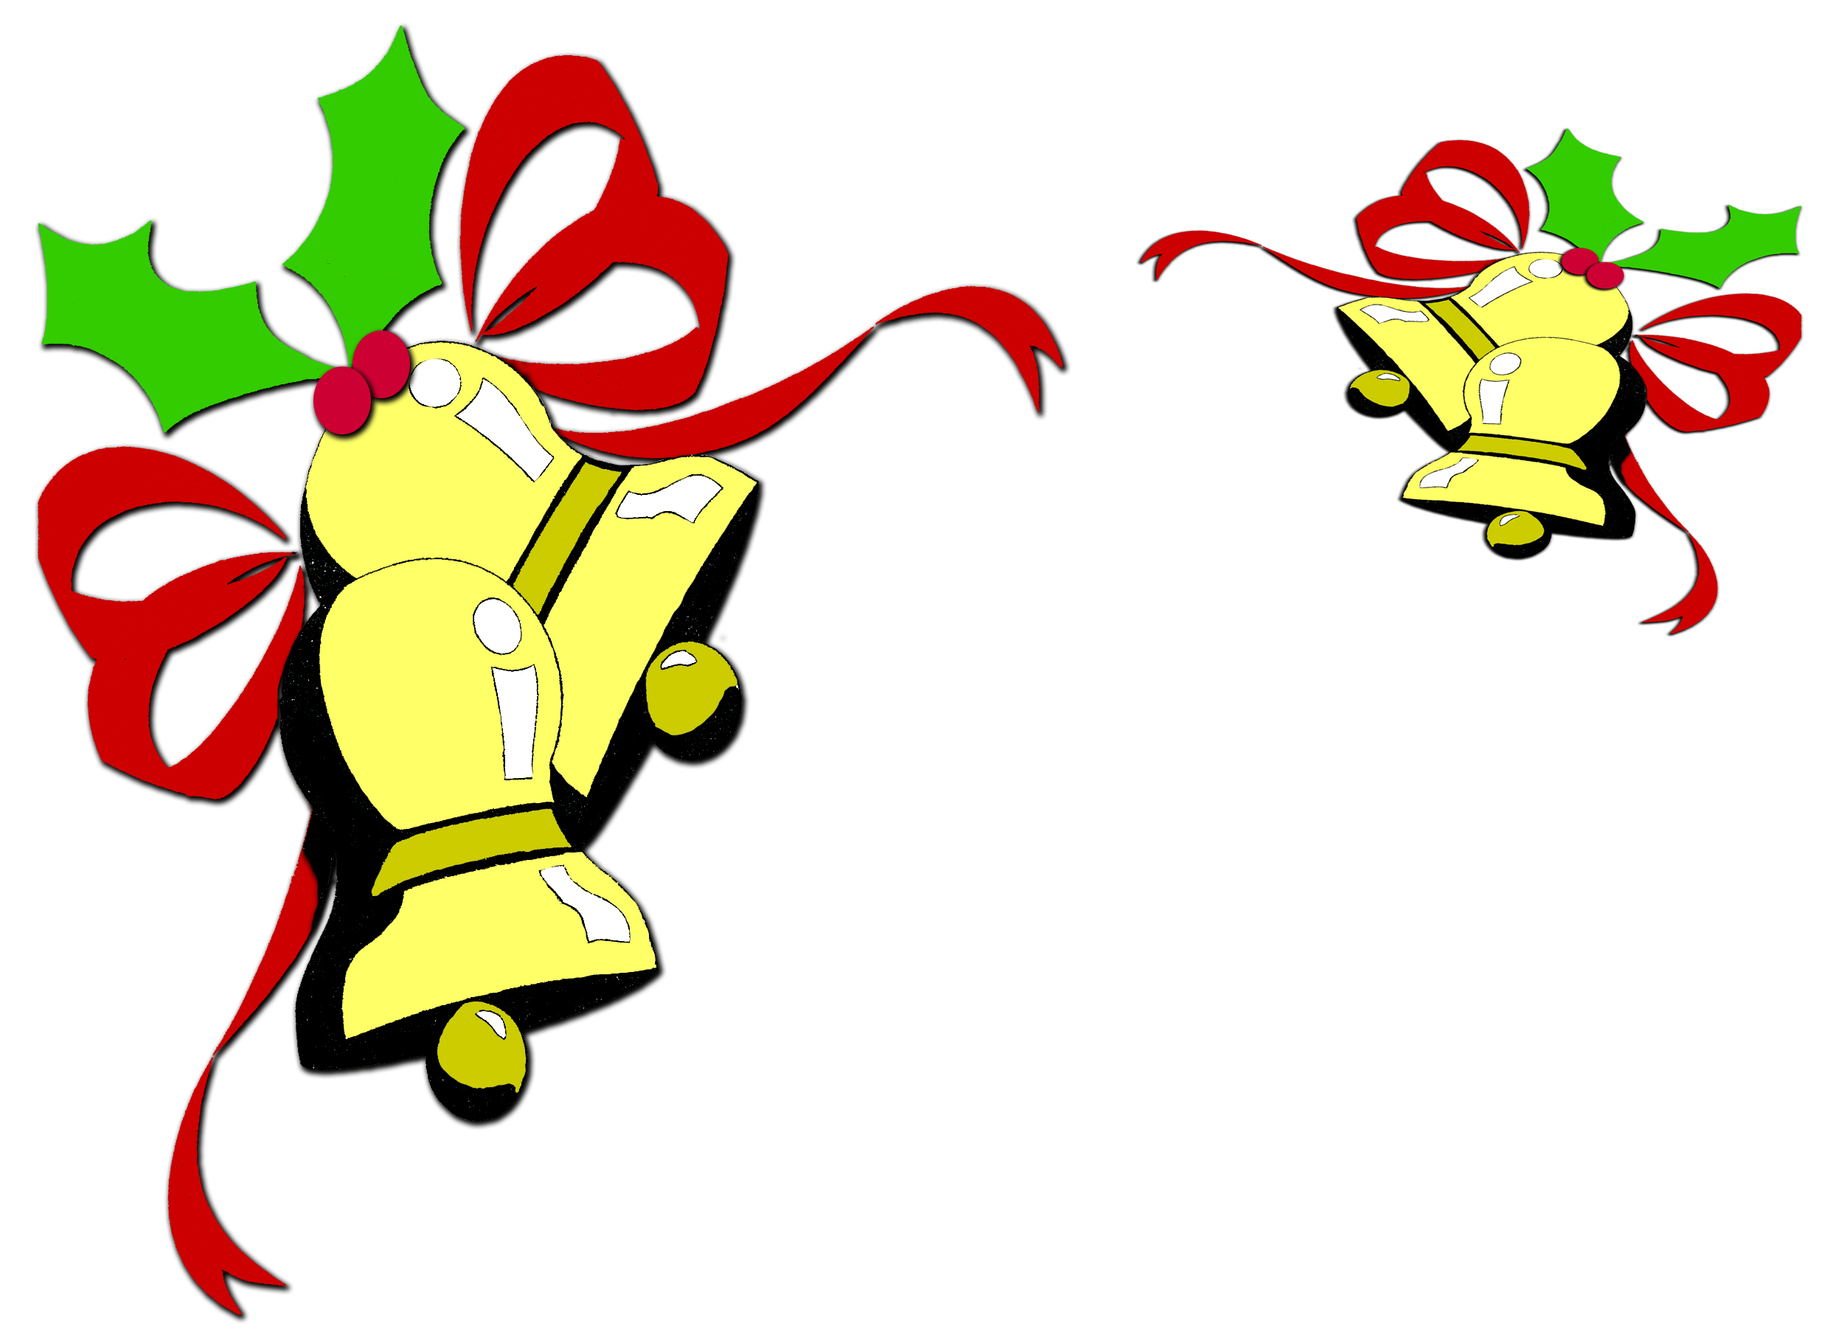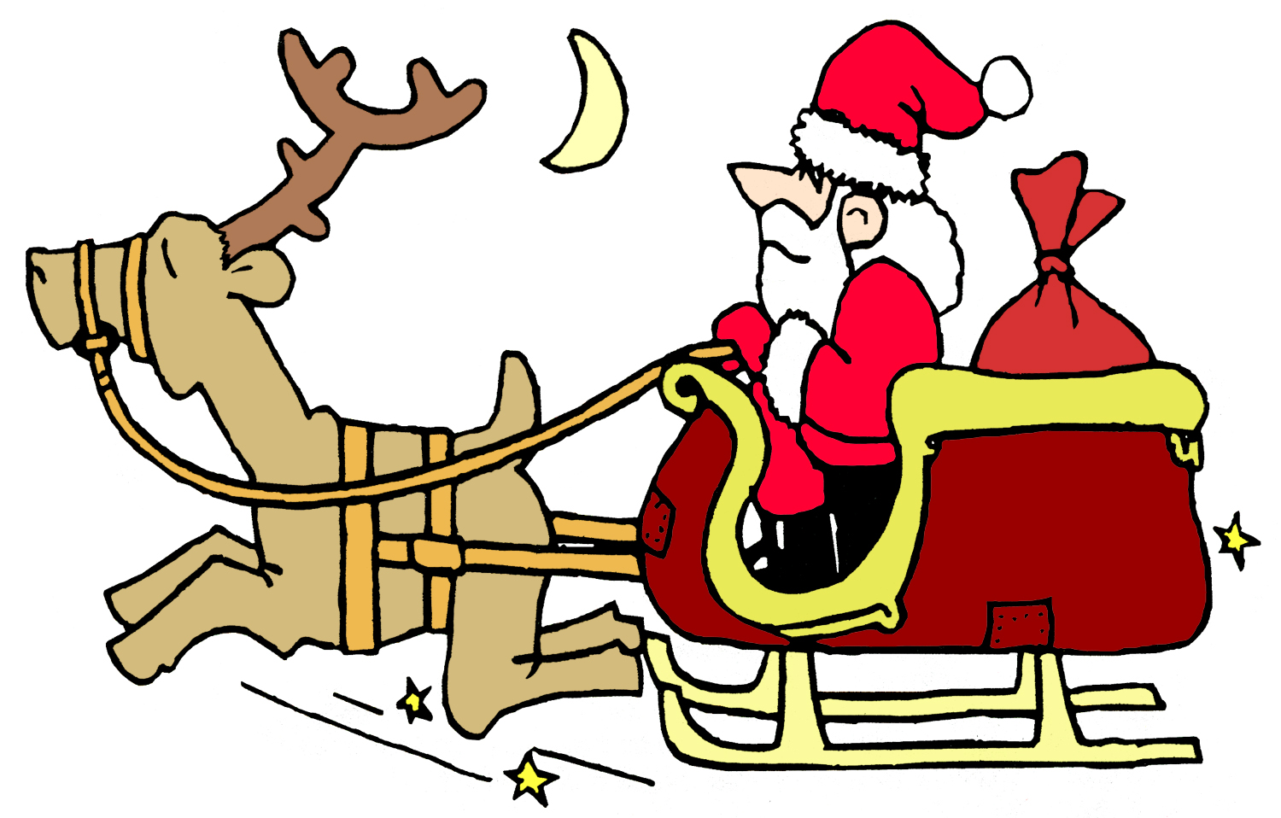

Indexers Are The Genealogist’s Best Friends

HSGS Web Site. <www.rootsweb.com/~usgenweb/mi/iosco/3501hsgs.htm> is the address for our HSGS's indexes on the Internet. The search engine for this site, or all of Michigan or any of the other Michigan’s counties is www.rootsweb.com/~usgenweb/mi/search.htm. We currently have (November 30 2006) 987 indexes, 24,425 printed pages, and 1,104,584 names indexed. All these files are on HSGS’s master file & the CD we sell, but only about 94% are on the web site (does not include new indexes within the last month, draft indexes not yet finished, & a some random data corrections). The status of our master indexes & CD follows:

Master Index Status | Dec | Jan | Feb | Mar | Apr | May | Jun | Jul | Aug | Oct | Nov
On the web, current | 735 | 742 | 768 | 785 | 811 | 834 | 830 | 835 | 849 | 871 | 877
On the web, out dated | 52 | 51 | 54 | 54 | 54 | 49 | 55 | 54 | 55 | 54 | 54
New, not yet sent to web | 7 | 29 | 16 | 22 | 17 | 3 | 6 | 14 | 16 | 5 | 13
Future, being edited | 14 | 21 | 21 | 14 | 6 | 6 | 8 | 7 | 7 | 7 | 7
Future, partially keypunched | 37 | 37 | 36 | 36 | 36 | 36 | 36 | 36 | 36 | 36 | 36
Totals | 849 | 880 | 895 | 911 | 924 | 928 | 935 | 946 | 963 | 973 | 987

HSGS member Dan Stock HSGS’s Web Master is placing our indexes directly on our USGENWEB web site.

Time to pay the 2007 dues. This year if you request it with your payment you will be sent a CD of our indexes. Our 987 indexes include 1,1004,584 names as of November 30 2006, and if printed out would be 24,925 pages long. Please sent your $10.00 membership check payable to the Huron Shores Genealogical Society, along with your current mailing & email address.

New Indexes Added This Month:
- Tawas Herald, Sep, Oct, Nov & Dec 1903. By Joan Doerr of Endicott City MD.
- WAFB Officers Wive’s Club Warbler; Sep & Oct 1963, Feb, Mar, Apr & Oct 1964, Jan & Mar 1963. By Jim Farrand of National City MI.
- The Saginaw Hall of Fame. By Alonzo J Sherman of Oscoda MI.

HSGS’s Treasurers Report (Nov 30 2006). Savings $1,206.81, Checking $581.07, cash $1.40, = Sub-Total $1,789.2879.10: Plus $249.98 cash card credit at Staples = Total of $2,039.26.

The Iosco County Historical Museum’s New History Book. The book is printed and expected to arrive at the museum any day.
Distance Calculator. Enter two latitude/longitude locations and the program will calculate the distance/direction from the first to the second location. (www.JewishGen.org/jobs/josdist.htm).
Mid-Continent Public Library. Check out this web site <www.mcpl.mo.us>, it is GOOD!
Preservation Tip. Allen County Public Library's Preservation Technician Becky Schipper offers advice on conserving your documents: Silica Gel can be used as a desiccant by placing it with damp materials to absorb moisture, or in an enclosed area as a buffer to maintain a specific relative humidity. Artifacts should not be in direct contact with the gel. (Genealogy Gems: News from the Fort Wayne Library, No. 33, November 30, 2006).
Copyright. Copyright law is complex, and the definitive site to refer to is <www.copyright.gov>/. The FAQ section is very helpful. This office states, “There is no specific number of words, lines, or notes that may be safely taken without permission.”
The Online Computer Library Center (OCLC) is a nonprofit, membership, computer library service and research organization dedicated to the public purpose of furthering access to the world’s information and reducing information costs. More than 55,000 libraries in 110 countries and territories around the world use OCLC services to locate, acquire, catalog, and lend and preserve library materials.
OCLC Announces Public Access Site for WorldCat. The Online Computer Library Center (OCLC) is a nonprofit, membership, computer library service and research organization dedicated to the public purposes of furthering access to the world’s information and reducing information costs. More than 55,000 libraries in 110 countries and territories around the world use OCLC services to locate, acquire, catalog, lend and preserve library materials.
OCLC has just announced that they are now allowing public access to their WorldCat catalog. Previously available only at libraries, WorldCat allows you to search the catalogs of their member libraries in a single step. Users can then located materials in a library close to them. Many articles and books are online and available for downloading directly from these libraries. Others may provide access to materials through interlibrary loan. WorldCat results often include a link to ASK a Librarian and other features at member libraries.
The new public-access interface also includes downloadable browser tools for Google and Yahoo toolbars. The new site for public access is currently in a beta test version and can be accessed at www.WorldCat.org. To find more about OCLC visit www.OCLC.org. (The Downriver Seeker, Nov 2006 p5).
Good Illinios Sites. The Illinois Archives (death, marriage etc for some time periods and counties), see <http//www.ilsos.net/departments/archives/datadase.html>, and the Chicago Tribune archives, see <hhtp://pqasb.pqarchiver.com/chicagotribune/advancedsearch.html>. (The Downriver Seeker, Nov 2006 p6).
Census Finder. This is a link to free census indexes, transcripts and images for US, UK, Canada, Norway & Sweden: <www.censusfinder.com>. (Northfield Gen Soc vol 19 no3 Sep/Oct 2006).

INDEXERS ROLL OF HONOR

See July 2006 Newsletter.

TRAINING AVAILABLE (One Time Events):

Year/Mo/Day | Description/Location/Contact
2007/01/06  Sat | Detroit Society for Genealogical Research, “Research at the Burton Historical Collections,” held at Christ Church, Cranbrook, Bloomfield Hills. Info 248-541-0403 or 313-884-0039 or <cpsrch@aol.com>.
2007/01/08-12  Mon-Fri | Salt Lake Institute of Genealogy. Contact www.infouga.org.
2007/02/10  Sat | Detroit Society for Genealogical Research, Research Trip tp Newly Renovated & Expanded Allen County Public Library, FtWayne IN. Info 248-541-0403 or 313-884-0039 or <cpsrch@aol.com>.
2007/03/10  Sat | Detroit Society for Genealogical Research, To be announced. Info 248-541-0403 or 313-884-0039 or <cpsrch@aol.com>.
2007/04/22  Sun | Detroit Society for Genealogical Research, Local History Conference, Wayne State University. Info 248-541-0403 or 313-884-0039 or <cpsrch@aol.com>.
2007/05/12  Sat | Detroit Society for Genealogical Research, Beginner’s Workshop. Info 248-541-0403 or 313-884-0039 or <cpsrch@aol.com>.
2007/07/13-14  Fri-Sat | Land Records & Genealogy Symposium, Southeast Community College, Beatrice NB. More info at kmorgan@southeast.edu or 800-233-5027.
2007/08/15-18  Wed-Sat | Federation of Genealogical Societies & Allen County Public Library will hold their conference “Meeting at the Crossroads of America”, at Grand Wayne Center, Ft Wayne IN. See <www.fgs/org/2007conf/FGS-2007.htm>.
2007/10/07  Sat | Washington DC Genealogy Tune-Up Tips. Fairfax VA Gen Soc 3rd Annual; Gen Fair, contact www.fxgs.org.

OTHER TRAINING:

- Individual Training Schedule (Recurring), see p10 of February 2005 Newsletter.

- Individual Training Schedule (By Appointment), see p11 of February 2005 Newsletter.

- Training Courses Online, see p11 of February 2005 Newsletter.

ANCESTRY LIBRARY EDITION

See August 2005 Newsletter.

SOME USEFUL GENEALOGICAL INTERNET ADDRESSES:

See June 2005 Newsletter. Prepared by Judy Sheldon. Please notify us at judesheldon@yahoo.com of any broken links or links you think should be added to this list. If you have any updates please let us know, as we will publish an updated list in the next few months.

HURON SHORES GENEALOGICALSOCIETY ACTIVE MEMBERS.

C/o Robert J Parks Public Library, 6010 N Skeel Ave, Oscoda MI 48750, and Phone 989-739-9581. The Library is open Mon, Fri & Sat 9:00am-5:00pm & Tue-Wed-Thur 9am-8:00pm (HSGS member available by chance or appointment). HSGS meetings are 6-7pm the 3rd Wednesday of Jan, Apr, and Jul & Oct in the Iosco County Historical Museum, 405 W Bay St (US-23), East Tawas MI. Officers, active project leaders, and indexers are listed below:

Name | Current Projects | Phone & E-mail
Birnbaum, Charles | Iosco County Death Indexes, News Herald Index, Saginaw News Obits | 989-362-5994 <Birnbaumcr@hotmail.com>
Carraway, Marianne | Hale Year Books | 989-739-9569 <mcarraway@charter.mi.net>
Daley, Lawrence | Hale Yearbook 1901-2002 | 248-253-7472 <daleymart@msn.com>
Daniels, Lugene | Burleigh Twp Farming | 989-756-3852
Doerr, Joan | Tawas Herald Newspaper Index | 410-461-1407 <JoanDoerr@hotmail.com>
Donaldson, James | Assists, His Oscoda Press Collection | 313-835-2440 <ab6943@wayne.edu>
Dressel, David | Transcribing various records | 480-838-4744 <ddressel@mail.cyberspeedway.net>
Durkin, Thomas | Transcribing various records | 904-273-8053 <TomPatDurkin@Yahoo.com>
Farrand, Jim | Transcribing the Warblers | 989-469-2308 <farrand@chartermi.net>
Johnson, Barbara | Transcribing various records | 952-934-7797, <bjohnson@edenpr.org>
Petee, Bonnie | Transcribing various records | 810-636-9348 <gypsy2@chartermi.net>
Sheldon, Judy | Treasurer | 989-739-5497 <judesheldon@yahoo.com>
Sherman, Alonzo | Librarian/Publications. Barkman Outfitter’s Day Book Indexes. | 989-739-3650 <shermanaj@hotmail.com>
Stock, Dan | Putting indexes on the Web Site | 989-739-4239 <etts95@yahoo.com>
Stonehouse, Naomi | President | 989-362-8187 <alvene2000@yahoo.com>
Summers. Leona | Oscoda Press Index | 989-724-6510 <none>

HISTORY OF THE HURON SHORES GENEALOGICAL SOCIETY

See March 2006 Newsletter.

MICHIGAN MANUALS FOR SALE

Send your check payable to the Iosco County Historical Society, 405 W Bay St (US-23), East Tawas MI 48730, 989-362-8911.

Year | Condition | Price
1897-1898 | Poor, Spin torn | $25
1899 | Fair | $35
1919 | Good | $20
1921 | Fair | $15
1949 | Good | $15
1951-1952 | Good | $15
1953-1954 | Good | $15
1957-1958 | Good | $15
1959-1960 | Good | $15
1963-1964 | Good | $15
1967-1968 | Good | $15
1969-1970 | Good | $15
1971-1972 | Good | $15
1973-1974 | Good | $15

FOR-FEE-RESEARCHERS

- Iosco County Michigan:
  - Naomi Stonehouse, 111 5th Ave, Tawas City Michigan 48763, 989-362-8187, alvena2000@yahoo.com.
  - Iosco County News-Herald, 110 W State St, POB 72, East Tawas MI 48730, 989-362-3456. Reportedly published articles can be purchased for $5.00 per page plus postage.
- Arenac County Michigan: Arenac County Historical Society & Museum, 304 E Michigan Ave, AuGres MI 48703, 989-876-6399.
- Other Michigan Counties: Inquire at the Library of Michigan for a list of for-fee-researchers, 717 Allegan St, Box 30007, Lansing MI 48909, 517-373-1580.



