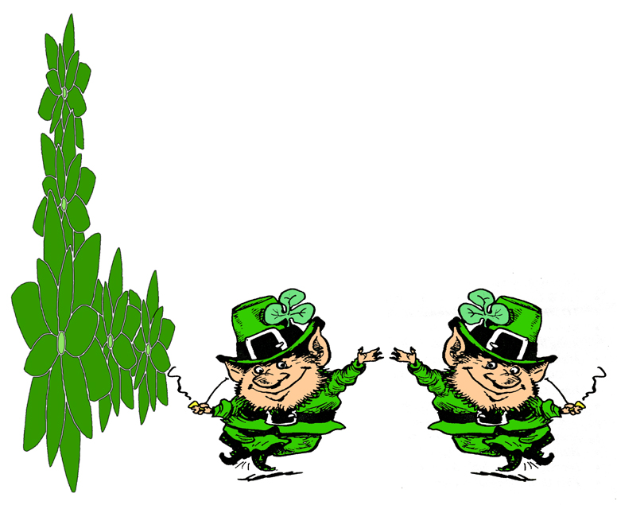

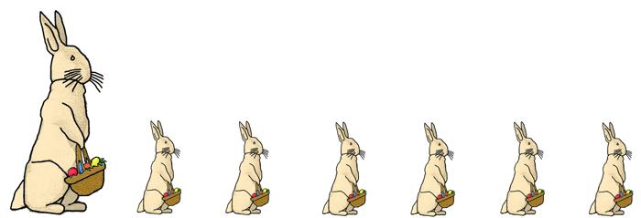

Indexers Are The Genealogist’s Best Friends

HSGS Web Site. <www.rootsweb.com/~usgenweb/mi/iosco/3501hsgs.htm> is the address for our HSGS's indexes on the Internet. The search engine for this site, or all of Michigan or any of the other Michigan’s counties is www.rootsweb.com/~usgenweb/mi/search.htm. We currently have (February 28 2007) 1,022 indexes, 25,452 printed pages, and 1,126,149 names indexed. All these files are on HSGS’s master file & the CD we sell, but only about 94% are on the web site (does not include new indexes within the last month, draft indexes not yet finished, & a some random data corrections). The status of our master indexes & CD follows:

Master Index Status | Mar | Apr | May | Jun | Jul | Aug | Oct | Nov | Dec | Feb
On the web, current | 785 | 811 | 834 | 830 | 835 | 849 | 871 | 877 | 891 | 904
On the web, out dated | 54 | 54 | 49 | 55 | 54 | 55 | 54 | 54 | 54 | 54
New, not yet sent to web | 22 | 17 | 3 | 6 | 14 | 16 | 5 | 13 | 13 | 20
Future, being edited | 14 | 6 | 6 | 8 | 7 | 7 | 7 | 7 | 7 | 7
Future, partially keypunched | 36 | 36 | 36 | 36 | 36 | 36 | 36 | 36 | 36 | 37
Totals | 911 | 924 | 928 | 935 | 946 | 963 | 973 | 987 | 1001 | 1022

HSGS member Dan Stock HSGS’s Web Master is placing our indexes directly on our USGENWEB web site.

Time to pay the 2007 dues. This year if you request it with your payment you will be sent a CD of our indexes. Please sent your $10.00 membership check payable to the Huron Shores Genealogical Society, along with your current mailing & email addresses.

New Indexes Added This Month:
- The Tawas Herald, Jan 1901 and Jan-Dec 1904. By John Doerr of Gettysburg PA.
- The Warbler. Nov 1962, Nov 1965, Oct 1966, Feb 1967, June 1975, Dec 1975 & Oct 1976. By Jim Farrand of National City MI.

New Books This Month: New England Historic Genealogical Society’s Lectures on Tape:
  - Researching Your Union Civil War Ancestor, with David Allen Lambert.
  - Finding a Wife’s Maiden Name, by David C Dearborn.
  - Genealogical Writing: Style Guidelines and Practical Advice, by Henry B Hoff.

HSGS’s Treasurers Report (February 28 2007). Savings $1,206.81, Checking $708.18, cash $2.00, = Total $1,916.99.

Interesting Web Sites:
  - www.interment.com
  - www.topozone.com
  - www.city-data.com
  - www.hometownlocator.com
  - www.FindMyPast.com (Passenger Lists Leaving British Ports)

Periodical Source Index (PERSI). PERSI is an index written on genealogy and local history. It covers US and Canadian materials published since 1800, with some going back into the 1700s. Covering 5,000 subscriptions and 10,000 titles, at the present time it includes over two million entries. PERSI can be searched online through Heritage Quest, which is available at many public libraries in the country. All publications indexed in PERSI are available in the Allen County Public Library’s Historical Genealogical Department, and can be request from this library. (The Downriver Seeker, v27 n1 p3).

Ireland On the Internet. Web site www.may-irelandJe/geneal will let you access the Family History Research Centers for each Irish County. (Saginaw Gen Soc Newsletter v29 i5 p455).

INDEXERS ROLL OF HONOR

See the January 2007 Newsletter, the next update is planned for July 2007.

TRAINING AVAILABLE (One Time Events):

January through March is the largest number of training programs during the year: Enjoy!

Year/Mo/Day | Description/Location/Contact
2007/03/10  Sat | Detroit Society for Genealogical Research, To be announced. Info 248-541-0403 or 313-884-0039 or <cpsrch@aol.com>.
2007/04/14  Sat | 30th Annual Spring Seminar-Genealogical Society of Monroe County (GSMC), MI, at the Monroe County Community College, Admin Bldg, 1555 S Raisinville Rd, Monroe MI 48161. Info at GSMC, POB 1428, Monroe MI 48161-6428.
2007/04/22  Sun | Detroit Society for Genealogical Research, Local History Conference, Wayne State University. Info 248-541-0403 or 313-884-0039 or <cpsrch@aol.com>.
2007/04/28  Sat | HSGS’s Spring training session- “Researching Canadian Genealogical Records,” speaker Roger Miller from Ontario, Canada. At Parks Public Library in Oscoda, MI, 12-5pm Saturday April 28 2007.
2007/05/12  Sat | Detroit Society for Genealogical Research, Beginner’s Workshop. Info 248-541-0403 or 313-884-0039 or <cpsrch@aol.com>.
2007/07/13-14  Fri-Sat | Land Records & Genealogy Symposium, Southeast Community College, Beatrice NB. More info at kmorgan@southeast.edu or 800-233-5027.
2007/07/20-21  Fre-Sat | Abrams Genealogy Seminar Details- Check Lib of Mi web site for details.
2007/08/15-18  Wed-Sat | Federation of Genealogical Societies & Allen County Public Library will hold their conference “Meeting at the Crossroads of America”, at Grand Wayne Center, Ft Wayne IN. See <www.fgs/org/2007conf/FGS-2007.htm>.
2007/10/07  Sat | Washington DC Genealogy Tune-Up Tips. Fairfax VA Gen Soc 3rd Annual; Gen Fair, contact www.fxgs.org.

OTHER TRAINING:

- Individual Training Schedule (Recurring), see p10 of February 2005 Newsletter.

- Individual Training Schedule (By Appointment), see p11 of February 2005 Newsletter.

- Training Courses Online, see p11 of February 2005 Newsletter.

ANCESTRY LIBRARY EDITION

See August 2005 Newsletter.

SOME USEFUL GENEALOGICAL INTERNET ADDRESSES:

See June 2005 Newsletter. Prepared by Judy Sheldon. Please notify us at judesheldon@yahoo.com of any broken links or links you think should be added to this list. If you have any updates please let us know, as we will publish an updated list in the next few months.

HURON SHORES GENEALOGICALSOCIETY ACTIVE MEMBERS.

C/o Robert J Parks Public Library, 6010 N Skeel Ave, Oscoda MI 48750, and Phone 989-739-9581. The Library is open Mon, Fri & Sat 9:00am-5:00pm & Tue-Wed-Thur 9am-8:00pm (HSGS member available by chance or appointment). HSGS meetings are 6-7pm the 3rd Wednesday of Jan, Apr, and Jul & Oct in the Iosco County Historical Museum, 405 W Bay St (US-23), East Tawas MI. Officers, active project leaders, and indexers are listed below:

Name | Current Projects | Phone & E-mail
Birnbaum, Charles | Iosco County Death Indexes, News Herald Index, Saginaw News Obits | 989-362-5994 <Birnbaumcr@hotmail.com>
Carraway, Marianne | Hale Year Books | 989-739-9569 <mcarraway@charter.mi.net>
Daniels, Lugene | Burleigh Twp Farming | 989-756-3852
Doerr, Joan | Tawas Herald Newspaper Index | 410-461-1407 <JoanDoerr@hotmail.com>
Donaldson, James | Assists, His Oscoda Press Collection | 313-835-2440 <ab6943@wayne.edu>
Dressel, David | Transcribing various records | 480-838-4744 <ddressel@mail.cyberspeedway.net>
Durkin, Thomas | Transcribing various records | 904-273-8053 <TomPatDurkin@Yahoo.com>
Farrand, Jim | Transcribing the Warblers | 989-469-2308 <farrand@chartermi.net>
Johnson, Barbara | Transcribing various records | 952-934-7797, <bjohnson@edenpr.org>
Petee, Bonnie | Transcribing various records | 810-636-9348 <gypsy2@chartermi.net>
Sheldon, Judy | Treasurer & Secretary | 989-739-5497 <judesheldon@yahoo.com>
Sherman, Alonzo | Librarian/Publications. Barkman Outfitter’s Day Book Indexes. | 989-739-3650 <shermanaj@hotmail.com>
Stock, Dan | Vice-president & web master | 989-739-4239 <etts95@yahoo.com>
Stonehouse, Naomi | President | 989-362-8187 <alvene2000@yahoo.com>
Summers. Leona | Oscoda Press Index | 989-724-6510 <none>

HISTORY OF THE HURON SHORES GENEALOGICAL SOCIETY

See March 2006 Newsletter.

MICHIGAN MANUALS FOR SALE

Send your check payable to the Iosco County Historical Society, 405 W Bay St (US-23), East Tawas MI 48730, 989-362-8911.

Year | Condition | Price
1897-1898 | Poor, Spin torn | $25
1899 | Fair | $35
1919 | Good | $20
1921 | Fair | $15
1949 | Good | $15
1951-1952 | Good | $15
1953-1954 | Good | $15
1957-1958 | Good | $15
1959-1960 | Good | $15
1963-1964 | Good | $15
1967-1968 | Good | $15
1969-1970 | Good | $15
1971-1972 | Good | $15
1973-1974 | Good | $15

FOR-FEE-RESEARCHERS

- Iosco County Michigan:
  - Naomi Stonehouse, 111 5th Ave, Tawas City Michigan 48763, 989-362-8187, alvena2000@yahoo.com.
  - Iosco County News-Herald, 110 W State St, POB 72, East Tawas MI 48730, 989-362-3456. Reportedly published articles can be purchased for $5.00 per page plus postage.
- Arenac County Michigan: Arenac County Historical Society & Museum, 304 E Michigan Ave, AuGres MI 48703, 989-876-6399.
- Other Michigan Counties: Inquire at the Library of Michigan for a list of for-fee-researchers, 717 Allegan St, Box 30007, Lansing MI 48909, 517-373-1580.



