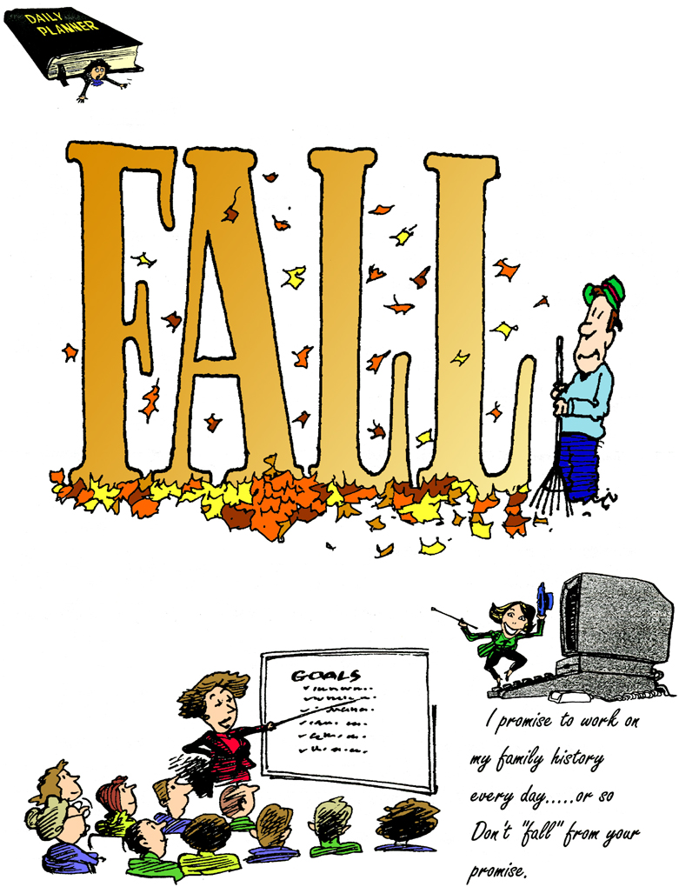

Indexers Are The Genealogist’s Best-Friend

HSGS’s Web Site. Our web site is no longer hosted by www.rootsweb.com and is now hosted by it’s own USGenWeb server, and has gone through several major changes in the last several months. And again this month there were several changes made. In HSGS’s opinion it still needs several more changes that are noted below in italics. Our current Internet address starts with www.usgenweb.org/mi, then the MIGenWeb - Michigan Home Pages opens, then click on the Alphabetical List of Michigan counties and then click on Iosco County. Three tables will appear: (1) Iosco County Resources table, (2) State of Michigan Resources table, and (3) United States National Resources table.
- If you wish to do a SIMPLE SEARCH of all Iosco County indexes (including HSGS indexes): From the Iosco County Resources table go to the search block titled Search the USGenWeb Archives in the lower right corner and enter your search words and click on the word <<Iosco. The Advance Search Menu will come on the screen (For some unknown reason) with your Simple Search results shown below it. (At this time the index titles do not appear in the search results until you click search results one at a time. We have asked that the index title be made mandatory, or at least optional, rather than the current format which is mostly uninformative).
- If you wish to do an ADVANCE SEARCH of all Iosco County indexes (Including HSGS indexes): From the Iosco County Resources table go to the search block titled Search the USGenWeb Archives in the lower right corner and click on the word <<Iosco and the Advanced Search Menu will appear. Fill in the options offered on the search menu (Be sure Iosco County is selected) and then click SEARCH and the search result will be presented below the Advance Search Menu. (At this time the index titles do not appear in the search results until you click search results one at a time. We have asked that the index title be made mandatory, or at least optional, rather than the current format which is mostly uninformative).
- If you wish only to BROWSE all of the HSGS indexes: Go to the Iosco County Resources table and click on Huron Shores Genealogical Society, and the USGenWeb home page for Iosco County & the Huron Shores Genealogical Society will open. This page is not prepared by HSGS, but by an USGenWeb volunteer, and is badly outdated, except for the first paragraph. In the first paragraph click on the words Main HSGS Index Page (shown in green), and all HSGS indexes will open up for browsing only because there is no search engine available here. (We have asked that a search engine be made available here). The Find Button (Ctrl-F) will afford some limited search of all the index titles, and also will afford some limited search of the content when an individual index is opened.
- If you wish to READ HSGS Newsletters from 2004-2008: Go to the Iosco County Resources table and click on Huron Shores Genealogical Society, and the USGenWeb home page for Iosco County & the Huron Shores Genealogical Society will (shown in green) and a list of our newsletters will appear. Select the MS-Word or PDF format and click on the date of the newsletter you want and the newsletter will open.
- MIGenWeb Megasearch. Starting this month, in the lower left corner of the Iosco County Resources table is an item titled MIGenWeb MegaSearch. HSGS has found no explanation given for what this is. It appears it might search all of USGenWeb except the USGenWeb Archives. If anyone knows what this is please advice us. Thanks.

HSGS currently has 1,273 indexes, 30,550 printed pages, and 1,345,078 name citations indexed: If the indexes were printed out they would be about 9 feet tall and weighs about 300 pounds.

All these files are on HSGS’s master file on our computers external hard drives, & on a 2-CD set that we sell. But only about 98% are on the web site (Which does not include about 10-20 new indexes within the last month or two, draft indexes not yet finished, & a some administrative corrections). The history and current status of our master indexes & CD follows:

Master Index Status | Sep | Oct | Nov | Dec | Jan | Feb | Mar | Apr | MAY | Jun | Jul | Aug
Current | 1063 | 1081 | 1104 | 1122 | 1130 | 1138 | 1147 | 1169 | 1178 | 1191 | 1201 | 1206
Outdated (Introduction) | 30 | 30 | 30 | 30 | 30 | 30 | 30 | 30 | 30 | 30 | 30 | 30
New This Month | 18 | 22 | 15 | 12 | 8 | 10 | 22 | 9 | 15 | 10 | 5 | 7
Editing In Progress | 7 | 7 | 7 | 7 | 7 | 7 | 7 | 7 | 6 | 6 | 6 | 6
Partially Done | 23 | 23 | 23 | 23 | 23 | 26 | 23 | 26 | 23 | 23 | 23 | 23
Totals | 1141 | 1163 | 1179 | 1194 | 1198 | 1211 | 1229 | 1241 | 1252 | 1258 | 1265 | 1272

HSGS member and Vice-president Dan Stock is HSGS’s Web Master and places our indexes directly on our USGENWEB web site.

Indexes Added This Month:
- The Herald: 1936(10) & 1936(11). By Joan Doerr of Ellicott City MD.
- The Warble Magazine (WAFB Officer’s Wives Club Newsletter): 1968(09); 1968(11); 1969(03); 1969(04); & 1969(05). By Barb Johnson of Eden Prairie MN.

New Books This Month, donated by Robert Parks Public Library:
- 1988 Keweenawan- Michigan Technological University, Houghton MI.
- 1987 Lumberjack- Oscoda High School.
- 1988 Lumberjack- Oscoda High School.
- 1989 Lumberjack- Oscoda High School.

Files Scanned This Month, by Alonzo Sherman:
- None.

HSGS’s Treasurers Report: Cash $31.76, Savings $1,262.92, Checking $670,67 = Total $1,965.35.

Iosco County Michigan Veteran’s Honor Roll Project: The list of veterans from Iosco County who served during wartime, and the web site, are being developed by HSGS for this project. A test web site has been established at www.IoscoVets.org. Comments requested. Thank you.

TRAINING AVAILABLE (One Time Events):

Year/Mo/Day | Description/Location/Contact
2008/Summer | The Traveling Exhibition, America’s Heritage: A History of U. S. Immigration is coming this summer to the Castle Museum in Saginaw MI. More info call Irene Hen singer at 989-752-2862 Ext 301.
2009/10/15-19 | Midland Genealogical Society Seminar, Valley Plaza Resort in Midland MI. More info later.

HURON SHORES GENEALOGICALSOCIETY ACTIVE MEMBERS.

C/o Robert J Parks Public Library, 6010 N Skeel Ave, Oscoda MI 48750, and Phone 989-739-9581. The Library is open Mon, Fri & Sat 9:00am-5:00pm & Tue-Wed-Thur 9am-8:00pm (HSGS member available by chance or appointment). Officers, active project leaders and indexers are listed below:

Name | Current Projects | Phone & E-mail
Anschuetz, Greta L | Transcribing the Warblers | 215-694-9332, <gretala80@yahoo.com>
Birnbaum, Charles | Iosco County Death Indexes, News Herald Index, Saginaw News Obits | 989-362-5994 <Birnbaumcr@hotmail.com>
Carraway, Marianne | WAFB Newspaper 1955-1993 | 989-739-9569 <mcarraway@charter.mi.net>
Daniels, Lugene | Secretary, Burleigh Twp Farming | 989-756-3852 <wrl@centurytel.net>
Doerr, Joan | Tawas Herald Newspaper Index | 410-461-1407 <JoanDoerr@hotmail.com>
Donaldson, James | Assists, with His Oscoda Press Collection | 313-835-2440 <ab6943@wayne.edu>
Farrand, Jim | Transcribing the Warblers | 989-469-2308 <farrand@charter.net>
Gervais, Eileen | Transcribing the Warblers | 989-469-3524  <jgervais@centrytel.net>
Johnson, Barbara | Transcribing the Warblers | 952-934-7797, <bjohnson@edenpr.org>
MacMurray, Jim | Tawas School Yearbooks | 330-824-34230  jimm14@aol.com
Odell, Anna | Iosco County Vets Project | 989-305-2396 <No E-mail>
Petee, Bonnie | Transcribing various records | 810-636-9348 <gypsy2@chartermi.net>
Sheldon, Judy | Treasurer & Secretary | 989-739-5497 <judesheldon@yahoo.com>
Sherman, Alonzo | Librarian/Publications/Indexes. | 989-739-3650 <shermanaj@hotmail.com>
Stock, Dan | Vice-president & web master | 989-739-4239 <etts95@yahoo.com>
Stonehouse, Naomi | President, writing local booklets | 989-362-8187 <alvene2000@yahoo.com>
Summers. Leona | Oscoda Press Index | PO Box 246, 3916 S Poor Farm Rd, Greenbush MI 48738,

GENEALOGICAL FINDING GUIDES Etc

Item | Quantity | Location In HSGS
Archives (Located in Bldg 200 WAFB) | 328 Titles, 105 CuFt | Reference Desk
Books for sale by Carol Dickinson | List of | Newsletter 2007(11)
Census MI 1894 | 1 35mm roll | Cabinet 1 drawer 7
Census US (MI) 1820-1920 | 24 35mm rolls | Cabinet 1 drawer 7
Census US (MI) 1870, 1880, 1900, 1920, | 5 CD-ROMs | Cabinet 1 drawer 8
Correspondence File | 86 linear feet | Cabinet 1 drawer 1-5
Files, work-in-progress | Flash Drive | Staff Computer Drive-M
For-Fee Researchers | List of Names | IN HSGS Handout on the Reference Desk & Newsletter 2007(12) p5
Handout. HSGS | 2 pages | Reference Desk
History of HSGS | Text | Newsletter 2007(12) p7
How-To-Do Genealogy | 96 Books | Stack 2 shelf 3-4
Indexers Roll-Of-Honor, HSGS’s |  | Newsletter 2007(12)p20
Internet Addresses, selected |  | Newsletter 2005(06)
Michigan Manuals for sale | List of | Newsletter 2007(06) p5
Names Indexes: Patron Computer | 1,200 indexes, 1.3 million names (9’ tall & 285 lbs) | Patron Computer Drive-Z
Names Indexes: Staff Computer | 1,200 indexes, 1.3 million names (9’ tall & 285 lbs) | Staff Computer Drive-L
Newsletters, HSGS’s | 5 years | Web-Site*
Newspaper- Gazette (Iosco Co) 1868-1947 | 36 35mm rolls | Cabinet 1 drawer 1-2L
Newspaper- Herald (Iosco Co) 1884-1928 | 20 35mm rolls | Cabinet 1 drawer 2R
Newspaper- Independent (Arenac Co) 1972-2000 | 33 35mm rolls | Cabinet 1 drawer 3
References, Canada | 240 Books | Stack 1 shelf 3-4
References, European Countries | 25 Books | Stack 1 shelf 1L
References, How-To-Do Genealogy | 96 Books | Stack 2 shelf 2-4
References, Iosco County MI | 243 Books | Stack 3 shelf 1-4
References, Loose Leaf (File prefix order) | 4 file cabinet draws | Cabinet 2 drawer 1-4
References, Michigan | 276 Books | Stack 4 shelf 1-2
References, Michigan Counties (-Iosco) | 280 Books | Stack 5 shelf 1-5
References, Published Family Histories | 111 Books | Stack 2 shelf 1-2
References, States (Other than MI) | 901 Books | Stack 4 shelf 1-2
References, United States | 103 Books | Stack 1 shelf 1R-2
Scanned References | 70 references, 3.8GB | Staff Computer Drive-K
Sign-In Sheet & price list | 1 page | Reference Desk
Surname Register | List of Patrons | Staff Computer Drive-L
Surname Register | List of names being researched & researchers: over 100 pages | Staff Computer Drive-L
Training Courses Online, Individual | List of Courses | Newsletter 2005(02) p11
Training Schedule, Individual (By Appointment) | List of Courses | Newsletter 2005(02) p11
Training Schedule, Individual (Recurring) | List of Courses | Newsletter 2005(02) p10
Volunteer Soldiers who served from Michigan during the Patriot War 1838-1839 | 1 16mm microfilm | Cabinet 1 drawer 7

