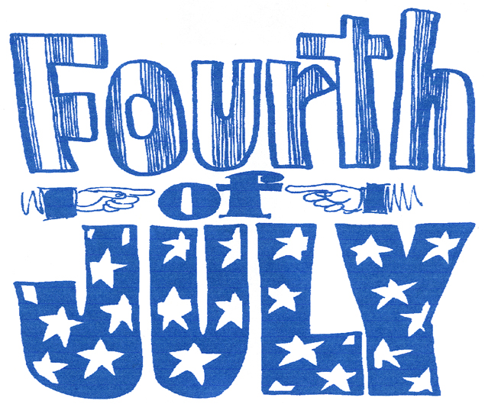



Indexers Are The Genealogist’s Best-Friend

HSGS’s Web Site. Our web site is no longer hosted by www.rootsweb.com and is now hosted by it’s own USGenWeb server, and has gone through several major changes in the last several months. In HSGS’s opinion it still needs several more changes that are noted below in italics. Our current Internet address starts with www.usgenweb.org/mi, then the MIGenWeb - Michigan Home Pages opens, then click on the Alphabetical List of Michigan counties and then click on Iosco County. Three tables will appear: (1) Iosco County Resources table, (2) State of Michigan Resources table, and (3) United States National Resources table.
- If you wish to do a SIMPLE SEARCH of all Iosco County indexes (including HSGS indexes): From the Iosco County Resources table go to the search block titled Search the USGenWeb Archives in the lower right corner and enter your search words and click on the word <<Iosco. The Advance Search Menu will come on the screen (For some unknown reason) with your Simple Search results shown below it. (At this time the index titles do not appear in the search results until you click search results one at a time. We have asked that the index title be made mandatory, or at least optional, rather than the current format which is mostly uninformative).
- If you wish to do an ADVANCE SEARCH of all Iosco County indexes (Including HSGS indexes): From the Iosco County Resources table go to the search block titled Search the USGenWeb Archives in the lower right corner and click on the word <<Iosco and the Advanced Search Menu will appear. Fill in the options offered on the search menu (Be sure Iosco County is selected) and then click SEARCH and the search result will be presented below the Advance Search Menu. (At this time the index titles do not appear in the search results until you click search results one at a time. We have asked that the index title be made mandatory, or at least optional, rather than the current format which is mostly uninformative).
- If you wish only to BROWSE all of the HSGS indexes: Go to the Iosco County Resources table and click on Huron Shores Genealogical Society, and the USGenWeb home page for Iosco County & the Huron Shores Genealogical Society will open. This page is not prepared by HSGS, but by an USGenWeb volunteer, and is badly outdated, except for the first paragraph. In the first paragraph click on the words Main HSGS Index Page (shown in green), and all HSGS indexes will open up for browsing only because there is no search engine available here. (We have asked that a search engine be made available here). The Find Button (Ctrl-F) will afford some limited search of all the index titles, and also will afford some limited search of the content when an individual index is opened.
- If you wish to READ HSGS Newsletters from 2004-2008: Go to the Iosco County Resources table and click on Huron Shores Genealogical Society, and the USGenWeb home page for Iosco County & the Huron Shores Genealogical Society will (shown in green) and a list of our newsletters will appear. Select the MS-Word or PDF format and click on the date of the newsletter you want and the newsletter will open.
- MIGenWeb Megasearch. Starting this month, in the lower left corner of the Iosco County Resources table is an item titled MIGenWeb MegaSearch. HSGS has found no explanation given for what this is. It appears it might search all of USGenWeb except the USGenWeb Archives. If anyone knows what this is please advice us. Thanks.
xxxxxxxxxxxxxxxxxxxxxxxxxxxxxxxxxxxxxxxxxxxxxxxxxxxxxxxxxxxxxxxxxxxxxxxxxxxxxxxxxxxxxxxx

HSGS currently has 1,317 indexes, 32,297 printed pages, and 1,417.656 name citations indexed on the computer: If the indexes were printed out they would be about 9 feet tall and weighs about 300 pounds.

All these files are on HSGS’s master computer file on our computers external hard drives, & on a 2-CD set that we sell for $10.00 post paid, and free on our USGWBWEB site.. But only about 98% are on the web site (Which does not include about 5-10 new indexes within the last month or two, draft indexes not yet finished, & the Iosco County Veterans Working Database which is not open to the public. The history and current status of our master indexes follows:

Master Index Status | Jul | Aug | Sep | Oct | Nov | Dec | Jan | Feb | Mar | Apr | May | Jun
Current | 1201 | 1206 | 1213 | 1219 | 1223 | 1228 | 1228 | 1230 | 1235 | 1239 | 1245 | 1245
Current, outdated Introduction | 30 | 30 | 30 | 30 | 30 | 30 | 30 | 30 | 30 | 30 | 30 | 30
New This Month | 5 | 7 | 5 | 4 | 5 | 0 | 6 | 2 | 4 | 5 | 0 | 13
Editing In Progress | 6 | 6 | 6 | 6 | 6 | 6 | 6 | 6 | 6 | 6 | 6 | 6
Partially Done | 23 | 23 | 23 | 23 | 23 | 23 | 23 | 23 | 23 | 23 | 23 | 23
Totals | 1265 | 1272 | 1277 | 1282 | 1287 | 1287 | 1293 | 1291 | 1298 | 1303 | 1304 | 1317

HSGS member Dan Stock is our Web Master and places our indexes directly on our USGENWEB site.

Books Added During May & June:
- The Germans, by Erich Kahler. Donated by the Friends of the Library.
- The Irish, by Thomas J O’Hanlon. Donated by the Friends of the Library.
- Ancestry’s Guide To Research, by Jobni Cerny & Arlene Eakle. Donated by Laura Merwin.
- Neikirk, Newkirk, Nikirt and Related Families Vol 1, by W N Hurley Jr. Donated by Laura Merwin.
- Land & Property Research In The US, by E Wade Hone. Bought by HSGS.
- The American Genealogist, #87,88,89, Jan-Apr-Jul 1941. Donated by the Friends of the Library.
- Whittemore-Prescott Schools (17 miscellaneous textual items list in the table below). Donated by the Arenac Historical Society.
Year/Mo/Dy | Vol | Items | #
1979-1980 | -- | Whittemore Elementary Center- Photos & Names of staff; & only photos of Kindergarten through 5th grade. | 1
1982 | -- | W-P High Times- Thanksgiving Issue (1982 Football ended) | 1
1983/09 | 01 | W-P High Times- Back To School | 1
1983/12 | 06 | Birth Bylines, A Publication Of Mid-Michigan Childbirth Education Association Inc | 1
1985 | 05 | W-P High Times- Spring Break, Easter (Reprint from Games Sep 1985 & 10 top movies of 1985) | 1
1985/05 | -- | W-P Cardinal Spirit- Class of 1985 | 1
1985/10 | 01 | W-P High Times- Welcome Back | 1
1985/11 | 02 | W-P High Times- Happy thanksgiving | 1
1985/12 | 03 | W-P High Times-Season’s Greetings | 1
1985/12/13 | -- | SADD Drinking-Driver Contract For Life- Poole, Jody A (Teenage) & Poole, Harold D Poole (Parent) | 1
1986 | 03 | W-P Class Act – Santa’s List (Sports Schedule 1986-87) | 1
1986/02 | 4 | W-P High Times- One From The Heart | 1
1986/05 | -- | W-P High Times- Class of 1986 | 1
1986/09-10 | 01 | W-P Class Act – Back to school & Rain &Homecoming & Halloween & Fall Sports | 1
1986/10-11 | 02 | W-P Class Act – Thanksgiving Issue | 1
1986/12/25 | Sec 1-2 | Ogemaw County Herald | 1
1987/02 | 04 | W-P Class Act – Dear Valentine | 1
TOTAL |  |  | 17

Indexes Added May & June:
- Iosco County Veterans Database from the Civil War thru the Vietnam War (Added only to HSGS’s master file, not on the CD or Internet files). Researched and Indexed by Alonzo Sherman of Oscoda MI and etal.
- Tawas Herald: 1941(05), 1941(08), 1941(09), 1941(10) & 1941(11). Indexed by Joan Doerr of Davis CA.
- Emery Lumbering Photo Collection. Indexed by Alonzo Sherman of Oscoda MI.

Items Scanned May & June:
- Emery Lumbering Photo Collection. Scanned by Alonzo Sherman of Oscoda MI.

HSGS’s Treasurers Report: See the Minutes for the last HSGS business meeting.

Iosco County Michigan Veteran’s Honor Roll Project: The list of veterans from Iosco County, who served during wartime, and the web site, are being developed by HSGS under contract with the Tawas City Hall. A test web site has been established since Nov 2008 at www.IoscoVets.org. A draft database of veterans from the Civil War through the Vietnam War was completed and sent to the website on January 7, 2009. The other newer wars are expected to work on with a new contract starting in 2009 or 2010.

HURON SHORES GENEALOGICALSOCIETY ACTIVE MEMBERS.

C/o Robert J Parks Public Library, 6010 N Skeel Ave, Oscoda MI 48750, and Phone 989-739-9581. The Library is open Mon, Fri & Sat 9:00am-5:00pm & Tue-Wed-Thur 9am-8:00pm (HSGS member available by chance or appointment). Officers, active project leaders and indexers are listed below:

Name | Current Projects | Phone & E-mail
Anschuetz, Greta L | Transcribing the Warblers | 215-694-9332, <gretala80@yahoo.com>
Birnbaum, Charles | Iosco County Death Indexes, News Herald Index, Saginaw News Obits | 989-362-5994 <Birnbaumcr@hotmail.com>
Carraway, Marianne | Alcona County- A Pictorial History Vols 1 & 2. | 989-739-9569 <mcarraway@charter.mi.net>
Daniels, Lugene | Secretary, Burleigh Twp Farms Booklet | 989-756-3852 <wrl@centurytel.net>
Doerr, Joan | Tawas Herald Newspaper Index | 410-461-1407 <JoanDoerr@hotmail.com>
Donaldson, James | Assists, with His Oscoda Press Collection | 313-835-2440 <ab6943@wayne.edu>
Gervais, Eileen | Transcribing the Warblers | 989-469-3524  <jgervais@centrytel.net>
Johnson, Barbara | Transcribing the Warblers | 952-934-7797, <bjohnson@edenpr.org>
MacMurray, Jim | Tawas School Yearbooks | 330-824-34230 jimm14@aol.com
Odell, Anna | Iosco County Vets Project & labeling HSGS’s Library collection | 989-305-2396 <No E-mail>
Petee, Bonnie | Transcribing various records | 810-636-9348 <gypsy2@chartermi.net>
Sheldon, Judy | President & Senior Researcher | 989-739-5497 <judesheldon@yahoo.com>
Sherman, Alonzo | Database Manager | 989-739-3650 <shermanaj@hotmail.com>
Stock, Dan | Vice-president & web master | 989-739-4239 <etts95@yahoo.com>
Stonehouse, Naomi | Writing local booklets | 989-362-8187 <alvene2000@yahoo.com>
Summers. Leona | Oscoda Press Index | PO Box 246, 3916 S Poor Farm Rd, Greenbush MI 48738,

TRAINING

Year/Mo/Dy | Description/Location/Contact
2009/06/16 Tue 6-8pm | Open Discussions About Iosco County MI Local History. At the Parks Public Library in Oscoda MI. Sponsored by the AuSable-Oscoda Historical Society & Museum: Call Ed Glotfelty at 989-739-3178. Donations appreciated.
2009/06/18 Thur 6-8pm | Roundtable Discussions about Genealogical Heritage Societies. Members of several Heritage Societies will attend to answer your questions. At the Parks Library in Oscoda MI. Sponsored by HSGS: 989-739-9581 or HuronShoresGS@Yahoo.com. Donations appreciated.
2009/06/25 Thur 7pm | Whalebacks on the Lakes by Ric Mister. Arenac Co Hist Soc Museum, 304 E MI Ave, AuGres MI, 989-876-6399. Donations appreciated.
2009/06/27 Sat 9am-4pm | Genealogical Seminar “Footnote & Fancy Tree” by keynote speaker Kris Rzepczynski of the Genealogy Section of the Library of MI. In the Alpena County Library. Sponsored by the Northeast Michigan Genealogical Society: 989-379-3303, nemgs@charter.net, www.nemga.com. Fee is $10.00 if paid by June 20th, or $15.00 if paid later (Lunch is included).
2009/06/27 Sat 8am | Iosco County Veterans Project Rummage Sale, 8am–6pm at the Tawas City Park. Rent a space available. If rained out rescheduled for July 18th. Info 989-362-8187.
2009/07/16 Thur 5:30pm | Huron Shores Genealogical Society business meeting at the Different Blend Coffee House, East Tawas MI. Public welcomed. Phone 989-739-9581.
2009/07/30 Thur 7pm | The Story of Spic ‘n Span, by Debbie Hanson. Arenac Co Hist Soc Museum, 304 E MI Ave, AuGres MI, 989-876-6399. Donations appreciated.
2009/08/27 Thur 7pm | Recollections of his father’s business at Point Lookout by Casey Wise. Arenac Co Hist Soc Museum, 304 E MI Ave, AuGres MI, 989-876-6399. Donations appreciated.
2009/10 | MI Genealogical Council Fall Seminar at Valley Plaza, Midland MI. Sponsored by the Midland Genealogical Society. Info at mimgc.org.
2009/10/03 Sat 1-3pm | Semi-Annual Genealogical Seminar On Records of the County Clerks Office. At the Grace Community Church, next door to the Parks Library in Oscoda MI. Sponsored by HSGS: Phone 989-739-9581 or HuronShoresGS@Yahoo.com. Donations appreciated.
2009/10/15 Thur 5:30pm | Huron Shores Genealogical Society business meeting at the Different Blend Coffee House, East Tawas MI. Public welcomed. Phone 989-739-9581.
2009/11/07 | MI Genealogical Council Fall Meeting, Speaker Dr Steven Morse. In the Library of MI Lansing MI. Info at mimgc.org.
2009/11/10 Tue 7pm | The Wheelsman: Lake Michigan & Lake Huron Wrecks, by Ric Mixter. At Ye Olde Courthouse & Masonic Lodge in Omer MI. 989-876-6399. Donations appreciated.
2009/08/20 Thur 6-8pm | Genealogy Help Session. Bring your pedigrees, family research & problems.

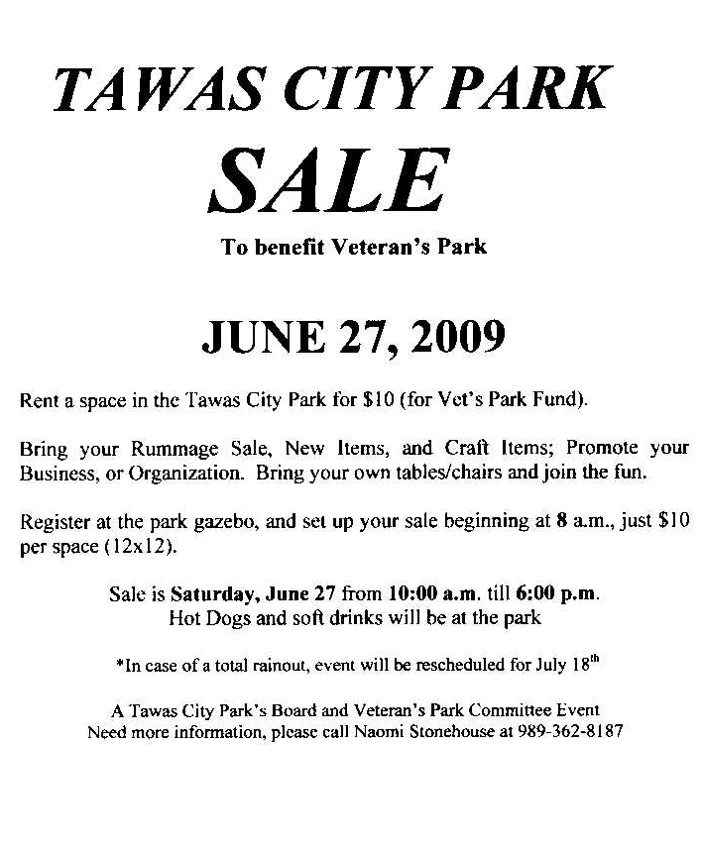
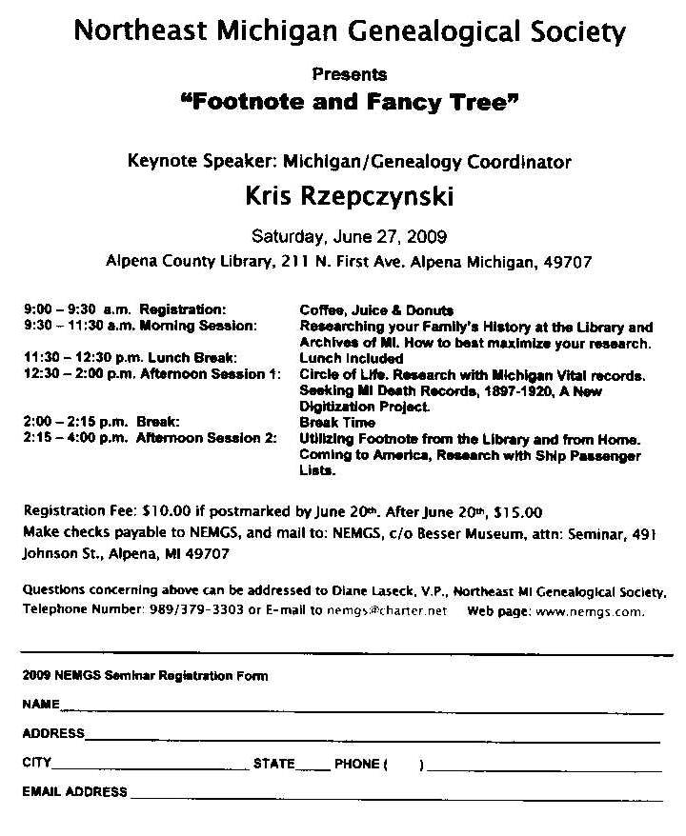

Italic date determined from inside text, not the cover.

